RouteWell Multi-Tier VNet Architecture
with Access Control
https://github.com/angelalabor/ROUTEWELL-MultiTier-VNet

NAME : ANGEL ALABOR
ID NUMBER: CLC/2026/TC-7/0176

About This Document
This document explains, in plain and simple language, every step I took to design, build, test, and document the RouteWell Multi-Tier VNet Architecture capstone project on Microsoft Azure. I wrote it so that even a person who has never used Azure before can read it from beginning to end and understand exactly what I did and why I did it.
Every technical word is explained the first time it appears. Every command is broken down piece by piece. Every problem I ran into is documented honestly, including the mistakes, the error messages, and how I solved them, because that is part of real cloud engineering work.

Project Workflow

Stage 1 — Understand the RouteWell client brief and success criteria.
Stage 2 — Create the GitHub repository, project structure, README, and .gitignore before Azure
deployment.
Stage 3 — Plan the architecture: Azure choice, CIDR/subnets, NSGs, access rules, and public access.
Stage 4 — Prepare the local development environment and Azure CLI.
Stage 5 — Deploy the Resource Group, VNet, subnets, NSGs, public IP, NICs, and supporting
infrastructure.
Stage 6 — Create the three Linux VMs and prove the required connectivity paths.
Stage 7 — Explain and maintain the Bash automation that reproduces the environment.
Stage 8 — Inject failures, investigate them, document root causes, and apply fixes.
Stage 9 — Complete the final Git/GitHub state and review the solution against the client requirements.
Stage 10 — Conclude with skills gained, lessons learned, real-world value, and teardown.

Phase 1 — Understanding the Project

1.1 What the Project Is Asking For
This capstone project asked me to design and build a secure computer network on Microsoft Azure for a made-up client called RouteWell. Azure is a cloud computing platform owned by Microsoft. A cloud computing platform is simply a company's data centre that I can rent computers, storage, and networking from over the internet, instead of buying my own physical servers.
The project is not just about making things work. It specifically tests whether I understand network segmentation. Network segmentation means splitting one big network into smaller, separate sections (called subnets) so that if one section has a security problem, the damage does not spread to the whole network.

1.2 The Client Scenario
RouteWell is described as a regional logistics company. A logistics company manages the movement of goods, like a delivery or dispatch business. In the scenario, RouteWell used to run all of its computers on one single flat network. A "flat network" means every computer can talk to every other computer with no restrictions at all.
The brief explains that this caused a near-miss data exposure: a contractor's laptop, sitting on the same network as RouteWell's database, could have reached sensitive driver and customer records simply because nothing was stopping it. Nothing bad happened this time, but the risk was real. This is the reason RouteWell hired a team (me) to redesign their network from scratch.

1.3 The Security Problem
The core problem is this: when every computer on a network can talk to every other computer, one weak or compromised device can become a doorway into everything else, including the most sensitive data. RouteWell's database holds driver and customer records, which is private, sensitive information. The database must never be exposed to devices or networks that do not need to reach it.

1.4 What the Client Wants
- The public-facing dispatch web app must be reachable from the internet, because customers and dispatch staff need to use it.
- The database holding driver and customer records must never be directly reachable from the internet, under any circumstance.
- Only the minimum necessary ports should be open between any two tiers — no "allow all internal traffic" shortcuts.
- The resource footprint should stay as lean and cost-effective as possible, because the company is budget-constrained this quarter.
- The design must have room to grow, because RouteWell expects dispatch staff (and app-tier traffic) to double within six months.

1.5 What the Deliverables Are
The brief asked for a specific, checkable set of outputs, not just "a working network." I had to produce:
- A GitHub repository containing my deployment scripts, NSG (Network Security Group) configuration, and an architecture diagram.
- A completed Phase 0 design worksheet, saved as a document inside the repository.
- Screenshots proving successful and blocked connectivity tests, taken before I deliberately broke anything.
- An incident report, written after I deliberately caused a failure and then diagnosed and fixed it.
- A README file explaining how to set up and tear down the whole environment.

1.6 What Success Looks Like
Success is not just "the VMs turned on." Success means: the web tier is reachable from the internet, the app tier can reach the database, the database cannot be reached directly from the internet or from the web tier, every open port has a documented reason, the whole thing can be rebuilt from a single script, and I can explain — in my own words — why every decision was made.

Phase 2 — Planning Before Deployment
Before I created a single resource in Azure, I made a set of tooling decisions. I am documenting the reasoning behind each one, because a design that "just happens to work" is not the same as a design that was actually thought through.

Why I Chose Microsoft Azure

Why Azure CLI Instead of the Azure Portal
The Azure Portal is the website with buttons and menus that lets a person click through to create resources. The Azure CLI (Command Line Interface) is a program I install on my own computer that lets me type text commands instead. I used the CLI, not the Portal, for three reasons:
- Repeatability — a CLI command can be saved in a script and run again exactly the same way every time. Portal clicks cannot easily be repeated or shared with someone else.
- The brief specifically required a Bash script that automates the full deployment end-to-end. That is only possible with CLI commands, not with manual Portal clicking.
- It creates a paper trail. Every command I ran is visible in this documentation and in my repository, which lets a grader (or future me) see exactly what was built and why.

2.3 Why Bash Scripting
Bash is the command language used by the terminal (in my case, Git Bash on Windows). I used Bash instead of another scripting language (like PowerShell or Python) because Azure CLI commands are written for a Unix-style shell, Bash is the standard choice for DevOps automation tasks, and it let me combine many `az` commands into one script that runs from start to finish without me retyping anything.

2.4 Why GitHub
GitHub is a website that stores my code and scripts in a "repository" (a project folder with a full history of every change). I used GitHub because the brief specifically required a GitHub repository as a deliverable, it lets my grader review my actual scripts and commit history instead of just trusting my word, and it gives me a permanent, shareable record of the project after my Azure resources are deleted.

2.5 Why Linux Virtual Machines
A Virtual Machine (VM) is a simulated computer that runs inside Azure's data centre. I chose Linux (specifically Ubuntu Server 22.04 LTS) for all three VMs because Linux is the standard operating system for servers in real-world cloud environments, it is free (no extra licensing cost, which matters given the budget-constrained brief), and Azure CLI tooling, package installers (`apt-get`), and networking test tools (`nc`, meaning netcat) are all straightforward to use on Linux.

Phase 3 — Network Design

3.1 Resource Group
A Resource Group is a container that holds every Azure resource belonging to one project. I named mine rg-routewell. Everything I built — the network, the security rules, the virtual machines — lives inside this one container. This matters for two reasons: it keeps the project organised, and it makes cleanup simple, because deleting the Resource Group deletes everything inside it in one action.

3.2 Virtual Network (VNet)
A Virtual Network, or VNet, is a private network that exists only inside my Azure account. It is the digital equivalent of a company's internal network cabling, except it lives in the cloud instead of a physical building. I created one VNet named vnet-routewell for the whole project. Every subnet, and every VM, lives inside this one VNet, which is what allows them to communicate privately with each other without going over the public internet.

3.3 Address Space
The Address Space is the full range of private IP addresses available inside the VNet. An IP address is a unique number that identifies a device on a network, similar to a street address for a house. I set the VNet's address space to 10.10.0.0/16.
The "/16" part is called a CIDR notation. CIDR stands for Classless Inter-Domain Routing, and it is simply a short way of saying how many addresses are inside a range. A /16 range gives 65,536 total addresses. I deliberately chose a large range like this so RouteWell has plenty of room to add more subnets in the future (for example, a reporting tier, or a VPN gateway) without having to redesign the network from scratch.

3.4 Subnets
A subnet is a smaller, separate section carved out of the main VNet's address space. Each tier of RouteWell's application — Web, App, and Database — sits in its own subnet. This is the actual mechanism of network segmentation: because each tier is in a different subnet, I can apply different security rules to each one.

3.4.1 CIDR Planning — How I Calculated Subnet Sizes
Azure reserves five IP addresses inside every subnet for its own internal use (the network address, the default gateway, two addresses for internal DNS, and the broadcast address). This means the number of addresses I can actually use in any subnet — the "usable hosts" — is always five less than the subnet's total size.
The brief told me exactly how many host machines each tier needs today, and how many it will need in six months. My job was to pick the smallest subnet size (CIDR mask) that comfortably fits both numbers, because picking a bigger size than necessary would waste address space and go against the brief's request to keep the design lean.
Tier | Hosts Today | Hosts in 6 Months | Mask Chosen | CIDR Range | Reasoning
Web | 12 | 12 (no stated growth) | /27 | 10.10.0.0/27 | A /28 subnet only gives 11 usable addresses (16 total minus 5 reserved), which is one short of the 12 hosts needed today, so it is disqualified immediately. A /27 gives 27 usable addresses, which comfortably covers 12 hosts with real room to spare, without jumping all the way up to a /26 (59 usable) that this tier has no stated need for.
App | 20 | 40 (expected to double) | /26 | 10.10.1.0/26 | The six-month number is the one that decides this, because the brief explicitly says app-tier traffic will double. A /27 (27 usable) fails immediately once the tier doubles to 40 hosts. A /26 gives 59 usable addresses, which covers the 40-host growth target with a safety margin, while a /25 (123 host capacity) would be far more than this tier will ever need.
Database | 6 | 6 (no stated growth) | /28 | 10.10.2.0/28 | A /29 gives only 3 usable addresses, which cannot even fit today's 6 hosts, so it is disqualified. A /28 gives 11 usable addresses — enough for today's 6 hosts plus room for a database replica later — without handing the most sensitive, least-trusted tier a needlessly large block of addresses.
Note: All three subnets fit inside the very first /24 slice of the /16 address space. This leaves the entire rest of 10.10.0.0/16 — from 10.10.3.0/24 all the way to 10.10.255.0/24 — completely untouched for future tiers, such as a reporting tier, a dedicated management subnet, or an Azure Bastion subnet.

3.4.2 Why Not Smaller?
I explained the specific reasoning for each tier in the table above, but the general rule is this: if a subnet mask does not have enough usable addresses to fit either today's host count or the six-month projection, it is automatically disqualified, no matter how much smaller (and therefore how much more "efficient looking") it would be.

3.4.3 Why Not Larger?
A bigger subnet than necessary wastes address space that could be used for other tiers later, and it also works against the brief's explicit instruction to keep the resource footprint lean. There is no security or performance benefit to over-sizing a subnet — Azure does not run any faster with more unused addresses sitting in a range.

3.4.4 Growth Planning and Future Scalability
Because the whole design lives inside a /16 address space but only uses the first /24 of it, RouteWell can add entirely new subnets — for a future reporting system, a VPN gateway, or a disaster-recovery site — without ever running out of room or needing to renumber the tiers that already exist. This is what "future scalability" means in a networking context: leaving room to grow without having to tear down and rebuild what already works.

Phase 4 — Access Control Design

4.1 What a Network Security Group Is
A Network Security Group, or NSG, is Azure's version of a firewall. A firewall is a set of rules that decides which network traffic is allowed to pass and which is blocked. I created one NSG per tier — web-nsg, app-nsg, and db-nsg — and attached each one to its matching subnet. This means the rules inside web-nsg apply to every device inside the Web subnet, and so on.

4.2 Inbound and Outbound Traffic, Explained Simply
Inbound traffic means data coming into a subnet from somewhere else. Outbound traffic means data leaving a subnet, going somewhere else. My entire design is only concerned with inbound rules, because I want to control exactly what is allowed to reach each tier. Azure allows all outbound traffic by default, which was acceptable for this project since the brief's security requirement is about protecting the database from being reached, not about restricting where the VMs themselves can send data.

4.3 Every NSG Rule I Created, and Why
Direction | Source | Destination | Port(s) | Why This Rule Exists / What Breaks Without It
Inbound | Internet | Web tier | 80, 443 | Port 80 is standard unencrypted web traffic (HTTP). Port 443 is encrypted web traffic (HTTPS). This is the one tier the brief requires to be reachable from the internet. Without this rule, the dispatch web app is unreachable and the whole project fails its core requirement.
Inbound | My own IP address only | Web tier | 22 | Port 22 is used for SSH, the protocol used to remotely log in to a Linux machine. Web is the only tier with a public IP address, so this is the only externally reachable management path in the entire design. Without it, I cannot administer any of the three VMs at all, because App and Database are reached by hopping through Web.
Inbound | Web subnet | App tier | 8080 | 8080 is the port the dispatch application listens on. This rule is the entire reason the tiers are separated in the first place. Without it, the web app cannot call its backend and the site does not work. With it, nothing outside the Web subnet — including the open internet — can reach port 8080 directly.
Inbound | Web subnet | App tier | 22 | App has no public IP address, so administrative SSH access has to arrive by hopping through the Web VM first. Without this rule, the App VM is completely unreachable for patching, debugging, or maintenance.
Inbound | App subnet | Database tier | 5432 | 5432 is the default port for PostgreSQL, the database engine I used. App is the only tier allowed to talk to the database. Without this rule, the application cannot read or write any driver or customer records and the whole system is non-functional.
Inbound | App subnet | Database tier | 22 | Same jump-host reasoning as the App rule above, one hop further along the chain. Without it, the only way to reach the Database VM would be Azure's built-in serial console, with no normal SSH access for maintenance.

4.4 Why Certain Traffic Is Blocked
Every request that is not explicitly listed in the table above is blocked automatically. Azure attaches a set of default rules to every NSG, and the very last one, called DenyAllInBound, blocks anything that does not match an earlier, more specific allow rule. I relied on this default deny rule to enforce the brief's requirement that the database must never be reachable except from the app tier.

4.5 A Design Gap I Discovered During Testing
While testing my network (documented fully in Phase 12), I discovered that Azure NSGs also come with a default rule called AllowVnetInBound, which permits traffic from any subnet in the VNet to reach any other subnet in the VNet, at a very low priority (meaning it is checked very late, but before the final deny-all rule). Because my Web-to-Database rule did not exist, I assumed traffic from Web to Database would be blocked by the final deny-all rule. In fact it was not blocked, because it matched this earlier, broader default-allow rule first.
I explain exactly how I found this, and how I fixed it with an additional explicit Deny rule, in Phase 12.

Phase 5 — Architecture Diagram
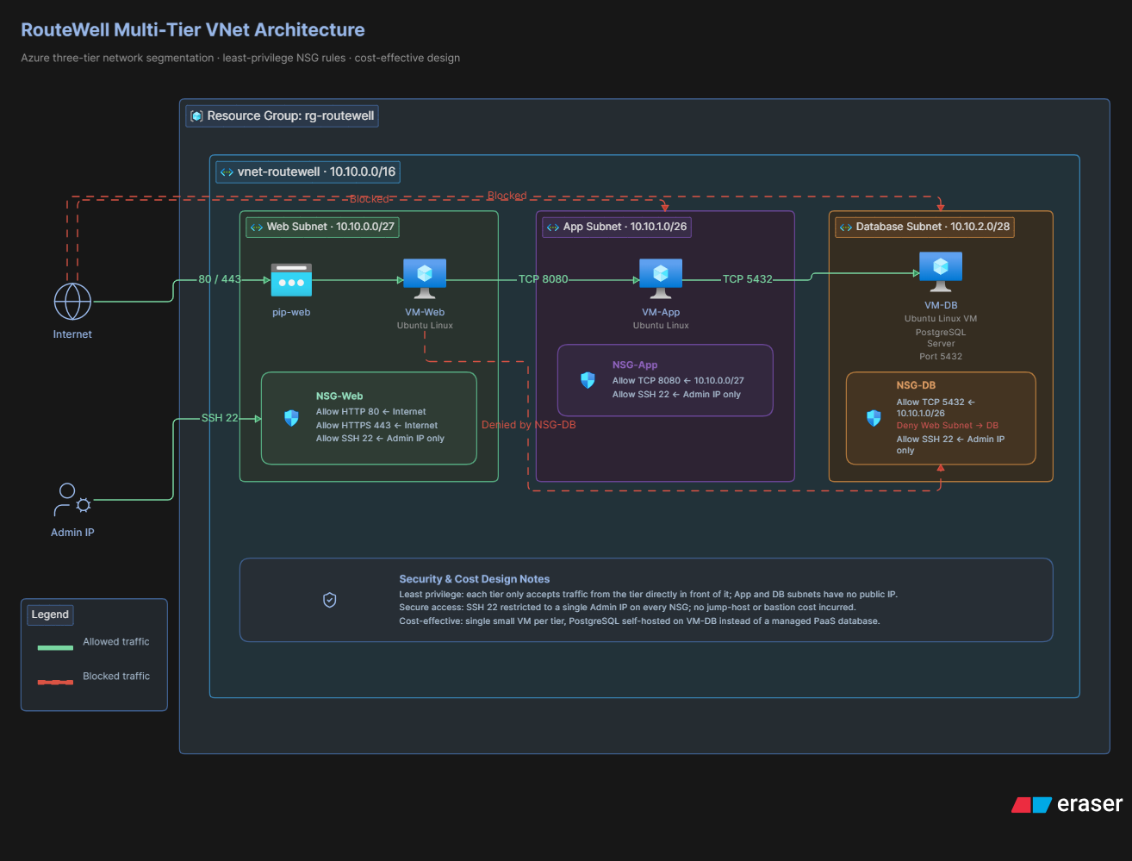

My architecture diagram shows the following elements, and I explain what each one means below:

5.1 The VNet Boundary
A large outer box represents the VNet itself (10.10.0.0/16). Everything else in the diagram sits inside this box, showing that all three tiers are part of one private network, isolated from every other Azure customer's network.

5.2 The Three Subnet Boxes
Inside the VNet box are three smaller boxes, one for each tier, each labelled with its CIDR range: Web (10.10.0.0/27), App (10.10.1.0/26), and Database (10.10.2.0/28). Each box represents a separate, isolated section of the network.

5.3 One VM Icon Per Subnet
Each subnet box contains one computer icon, representing the single Linux virtual machine running in that tier.

5.4 The Arrows and What They Mean
Every arrow in the diagram represents an allowed direction of traffic, and matches exactly one row from the NSG rule table in Phase 4:
- Internet → Web (ports 80, 443): the public entry point for dispatch users.
- My admin IP → Web (port 22): the only external management access point.
- Web → App (port 8080): the web app calling its backend.
- Web → App (port 22): the administrative jump-host path.
- App → Database (port 5432): the application reading and writing records.
- App → Database (port 22): the administrative jump-host path, one hop further.
Critically, there is no arrow at all from Web to Database, and no arrow from the Internet to App or Database. That absence is not a mistake — it is the entire point of the design. If a reader can look at the diagram and see that there is genuinely no path from the internet straight to the database, the diagram has done its job.

5.5 The Public IP Icon
A public IP icon sits only next to the Web VM, and nowhere else in the diagram. This visually reinforces that Web is the only tier reachable from outside the VNet at all — App and Database simply have no door for outside traffic to knock on, regardless of what any firewall rule says.

5.6 How Traffic Actually Flows
When a customer opens the RouteWell dispatch website in their browser, their request travels over the public internet to Web VM's public IP address on port 443. Web VM then makes its own request, over the private network, to App VM on port 8080. App VM, in turn, opens a connection to Database VM on port 5432 to read or write the data it needs. The response then travels back the same way it came. At no point does a request from the internet skip directly to App or Database — every request must pass through Web first, and every database request must pass through App first.

Phase 6 — Preparing the Development Environment
Before writing or running any Azure commands, I set up my local development environment. I worked from a Windows computer, using Git Bash as my terminal, so a few of these steps include Windows-specific notes.

6.1 Installing Azure CLI
Azure CLI is the program that translates the commands I type into requests that Azure's servers understand. I installed it once on my computer. After installing, I confirmed it worked by checking my account:
az account show
This command asks Azure "who am I logged in as, and which subscription am I using right now?" A subscription is the billing container that all my Azure resources are charged against. If this command shows my account details, Azure CLI is installed correctly and I am logged in.

6.2 Logging In and Selecting a Subscription
Before running any resource-creating commands, I made sure I was logged in with:
az login
This opens a browser window where I sign in with my Microsoft account. Once signed in, Azure CLI remembers my login for future commands in that terminal session, until I log out or the session expires.

6.3 Installing Git
Git is the version control program that tracks every change I make to my project files. I installed Git for Windows, which also comes with Git Bash, the terminal I used for every command in this project.

6.4 Installing VS Code
VS Code (Visual Studio Code) is the text editor I used to write and edit my Bash scripts and Markdown documentation files. I chose it because it has built-in syntax highlighting for Bash scripts, which makes mistakes like a missing backslash easier to spot visually.

6.5 Creating the GitHub Repository
I created a new, empty repository on GitHub named routewell-vnet-capstone, then cloned it (downloaded a local copy) to my computer with:
git clone https://github.com/<my-username>/routewell-vnet-capstone.git
cd routewell-vnet-capstone

6.6 Creating Project Folders
Inside the cloned repository, I created a folder structure to keep design documents, scripts, and screenshots organised and separate:
mkdir -p design scripts screenshots
touch README.md incident-report.md
touch design/phase0-worksheet.md
touch scripts/deploy.sh scripts/cleanup.sh
The mkdir -p command creates new, empty folders. The -p option tells it to also create any parent folders needed, and to not show an error if the folder already exists. The touch command creates a new, empty file — I used it here to reserve the filenames I planned to fill in later.

6.7 A Windows-Specific Environment Fix
Git Bash on Windows has a quirk: it automatically tries to convert Unix-style text (like file paths starting with a slash) into Windows-style paths. This causes a real problem for Azure networking commands, because a CIDR range like 10.10.0.0/27 also starts with something that looks like a path, and Git Bash was silently corrupting it into a broken Windows path string before Azure CLI ever saw it.
I fixed this by running the following command once, at the start of every terminal session, before any Azure CLI networking command:
export MSYS_NO_PATHCONV=1
This tells Git Bash to stop automatically converting paths for that terminal session, so CIDR ranges are passed to Azure CLI exactly as I typed them.
Warning: This same setting caused a separate, opposite problem later in the project — it also stopped my SSH key file path from being converted correctly, which caused virtual machine creation to fail. I explain this fully, including how I fixed it, in Phase 12.

Phase 7 — Deployment
This is the largest section of this document, because it covers every single Azure CLI command I ran to build the network, in the exact order I ran them. For each command, I explain what it does, why I needed it, what Azure actually creates as a result, how I verified it worked, and any errors I hit.

7.1 Getting My Public IP Address
ADMIN_IP=$(curl -s -4 ifconfig.me)
curl is a small program that fetches data from a website. ifconfig.me is a website that, when visited, simply replies with the visitor's own public IP address — the address my home network uses to reach the internet. I needed this address so I could later create a firewall rule allowing SSH access only from my own computer, and nowhere else. I stored the result inside a variable named ADMIN_IP, using the $(...) syntax, which runs the command inside the parentheses and captures its output as text.
Why the -4 option matters: curl -s -4 ifconfig.me forces the request to use IPv4 (the older, more common style of IP address, written like 98.97.79.54). Without -4, my home network sometimes returned an IPv6 address instead (a longer, different-looking address). Azure's NSG rules expect a /32 suffix, which only makes sense for IPv4 addresses, so an IPv6 address caused a real error later. I document that error, and this exact fix, fully in Phase 12.

7.2 Setting My Variables
Before creating any resources, I defined every name and value I would reuse throughout the script as a variable, so I only had to type each value once and could not accidentally misspell a resource name partway through the script.
LOCATION="westeurope"
RG="rg-routewell"
VNET="vnet-routewell"
ADDRESS_SPACE="10.10.0.0/16"
WEB_SUBNET="web-subnet"; WEB_PREFIX="10.10.0.0/27"
APP_SUBNET="app-subnet"; APP_PREFIX="10.10.1.0/26"
DB_SUBNET="db-subnet"; DB_PREFIX="10.10.2.0/28"
A variable in Bash is simply a name that stores a piece of text so it can be reused. Writing RG="rg-routewell" means that from now on, typing $RG anywhere in the script is exactly the same as typing rg-routewell by hand.

7.3 Creating the Resource Group
az group create \
--name "$RG" \
--location "$LOCATION"
az group create is the command that creates a new, empty Resource Group. The --name option sets its name, and --location sets which physical Azure data centre region it lives in — I chose westeurope. Azure CLI commands are commonly split across several lines using the backslash (\) character, which tells Bash "this command continues on the next line" — it is purely for readability and does not change what the command does.
Once this command finished, Azure created an empty container that everything else in this project lives inside. I verified it worked because the command printed back a JSON response showing "provisioningState": "Succeeded".

7.4 Creating the Virtual Network and First Subnet
az network vnet create \
--resource-group "$RG" \
--name "$VNET" \
--address-prefixes "$ADDRESS_SPACE" \
--subnet-name "$WEB_SUBNET" \
--subnet-prefix "$WEB_PREFIX"
This single command does two things at once: it creates the VNet itself, and — because Azure requires every new VNet to have at least one subnet — it also creates the first subnet (Web) inside it. --resource-group tells Azure which container to place this resource in. --name sets the VNet's name. --address-prefixes sets the whole /16 address range for the VNet. --subnet-name and --subnet-prefix set the name and CIDR range of the one subnet being created alongside it.

7.5 Creating the Remaining Two Subnets
az network vnet subnet create \
--resource-group "$RG" --vnet-name "$VNET" \
--name "$APP_SUBNET" --address-prefix "$APP_PREFIX"
az network vnet subnet create \
--resource-group "$RG" --vnet-name "$VNET" \
--name "$DB_SUBNET" --address-prefix "$DB_PREFIX"
Because the VNet already exists, adding the App and Database subnets uses a different command: az network vnet subnet create. --vnet-name tells Azure which existing VNet to add the subnet into. I verified all three subnets existed and had the correct address ranges by listing them:
az network vnet subnet list --resource-group "$RG" --vnet-name "$VNET" --output table
The --output table option formats the response as a readable table instead of raw JSON text, which made it easy to visually confirm all three CIDR ranges were exactly what I had planned in Phase 3.

7.6 Creating the Network Security Groups
az network nsg create --resource-group "$RG" --name web-nsg --location "$LOCATION"
az network nsg create --resource-group "$RG" --name app-nsg --location "$LOCATION"
az network nsg create --resource-group "$RG" --name db-nsg --location "$LOCATION"
Each of these three commands creates one empty NSG — a container for firewall rules, with no rules inside it yet. I created one per tier so that each tier's rules could be managed completely separately from the others.

7.7 Associating NSGs with Subnets
az network vnet subnet update \
--resource-group "$RG" --vnet-name "$VNET" \
--name "$WEB_SUBNET" --network-security-group web-nsg
(Repeated for app-subnet/app-nsg and db-subnet/db-nsg.) This command tells Azure "attach this NSG to this subnet," which means every rule inside that NSG now automatically applies to any device placed in that subnet — including virtual machines I had not created yet at this point in the script.

7.8 Creating the NSG Rules
I created six rules total, two per tier, exactly matching the design I justified in Phase 4. Here is one full example, with every option explained; the remaining five rules follow the identical pattern with different values.
az network nsg rule create \
--resource-group "$RG" \
--nsg-name web-nsg \
--name Allow-HTTP-HTTPS \
--priority 100 \
--direction Inbound \
--access Allow \
--protocol Tcp \
--source-address-prefix "Internet" \
--source-port-range "*" \
--destination-port-ranges 80 443
Option | Plain-English Meaning
--nsg-name | Which NSG this rule is being added to (web-nsg in this example).
--name | A label I choose for the rule, so I can identify it later. I named mine descriptively, like Allow-HTTP-HTTPS.
--priority | A number from 100 to 4096 that decides the order rules are checked in. Lower numbers are checked first. As soon as one rule matches a piece of traffic, Azure stops checking and applies that rule's decision — it never keeps looking at lower-priority rules after a match.
--direction | Either Inbound (traffic coming in) or Outbound (traffic leaving). All six of my rules are Inbound.
--access | Either Allow or Deny — what happens to traffic that matches this rule.
--protocol | The type of network traffic. Tcp is the reliable, connection-based protocol used by web traffic, SSH, and database connections. An asterisk (*) means any protocol.
--source-address-prefix | Where the traffic is allowed to come from. This can be a specific IP address, a CIDR range like a subnet, or the special word Internet, meaning any public internet address.
--source-port-range | Which port on the sending device the traffic is allowed to come from. I set this to "*" (any) on every rule, because the source port for outgoing connections is usually random and not something worth restricting.
--destination-port-ranges | Which port(s) on the receiving device the traffic is allowed to reach. This is the actual "door" the rule opens — 80 and 443 for web traffic in this example.
I ran this same pattern five more times, changing only --nsg-name, --name, --priority, --source-address-prefix, and the destination port, to create the remaining rules exactly as documented in the Phase 4 table: SSH access to Web from my own IP only, App-tier access from the Web subnet on ports 8080 and 22, and Database-tier access from the App subnet on ports 5432 and 22.

7.9 Creating the Public IP Address
az network public-ip create \
--resource-group "$RG" \
--name web-pip \
--location "$LOCATION" \
--sku Standard \
--allocation-method Static
This creates one public IP address, an address reachable from anywhere on the internet. --sku Standard chooses Azure's more secure, production-grade tier of public IP (as opposed to the older Basic tier). --allocation-method Static means the address, once assigned, never changes for as long as the resource exists — important, because a changing public IP would break access every time it changed.
Important design point: I only ever created one public IP address in this entire project, and it was only ever attached to the Web VM. This is the actual technical mechanism that makes the database unreachable from the internet — App and Database VMs simply have no public address at all, so there is no internet route to them, regardless of any firewall rule.

7.10 Creating the Network Interfaces
az network nic create --resource-group "$RG" --name web-nic \
--vnet-name "$VNET" --subnet "$WEB_SUBNET" --public-ip-address web-pip
az network nic create --resource-group "$RG" --name app-nic \
--vnet-name "$VNET" --subnet "$APP_SUBNET"
az network nic create --resource-group "$RG" --name db-nic \
--vnet-name "$VNET" --subnet "$DB_SUBNET"
A NIC (Network Interface Card) is the virtual equivalent of a network cable plugging a VM into a subnet. Every VM needs one NIC to be part of a network at all. Notice that only web-nic includes --public-ip-address web-pip — app-nic and db-nic deliberately do not, which is what leaves them with no public IP address.

Phase 8 — Virtual Machines

8.1 Creating an SSH Key Pair
SSH (Secure Shell) is the standard, encrypted way to remotely log in to a Linux machine and run commands on it. Instead of a password, SSH normally uses a key pair: a private key, which I keep secret on my own computer, and a public key, which I give to the server. The server allows anyone who can prove they hold the matching private key to log in, without ever sending a password over the network.
I generated my key pair once, with:
ssh-keygen -t rsa -b 4096
-t rsa selects RSA, a widely trusted encryption algorithm for SSH keys. -b 4096 sets the key length to 4096 bits, a strong, modern key size. I pressed Enter through the prompts to accept the default file location (~/.ssh/id_rsa) and to skip setting an extra password on the key itself.

8.2 Creating the Web VM
az vm create \
--resource-group "$RG" \
--name web-vm \
--nics web-nic \
--image Canonical:0001-com-ubuntu-server-jammy:22_04-lts-gen2:latest \
--size Standard_D2s_v3 \
--admin-username azureuser \
--ssh-key-values ~/.ssh/id_rsa.pub
Option | Plain-English Meaning
--name | The VM's name inside Azure — web-vm.
--nics | Which network interface to attach — this is what places the VM into the Web subnet and gives it its public IP.
--image | Which operating system image to install. This long string is called a URN (Uniform Resource Name) and precisely identifies Ubuntu Server 22.04 LTS, Generation 2, from the publisher Canonical.
--size | The hardware specification — how many virtual CPUs and how much memory the VM gets. I explain my sizing decision, including problems I ran into, in Phase 12.
--admin-username | The Linux user account I log in as — azureuser.
--ssh-key-values | The path to my public key file, which Azure installs on the VM so I can log in with my matching private key.
Web VM is the only one of the three placed on the web-subnet and the only one given a NIC that has a public IP attached, which is exactly why it is the only tier reachable directly from the internet.

8.3 Creating the App VM
I ran the identical command, changing only --name to app-vm and --nics to app-nic. This places App VM inside the App subnet, protected by app-nsg, with no public IP address.

8.4 Creating the Database VM
Same pattern again, with --name db-vm and --nics db-nic, placing Database VM inside the Database subnet, protected by db-nsg, also with no public IP address.

8.4.1 Evidence — A Complete, Successful deploy.sh Run
Below is the real terminal output from a full, clean run of deploy.sh, captured after deleting the resource group and rebuilding it from nothing, to prove the script genuinely reproduces the entire environment end to end rather than only working the first time it was ever run by hand.
$ bash scripts/deploy.sh
Getting your public IP...
Admin IP: 98.97.79.43
Creating Resource Group...
{ "name": "rg-routewell", "properties": { "provisioningState": "Succeeded" } }
Creating Virtual Network... -> vnet-routewell, 10.10.0.0/16, Succeeded
Creating Web Subnet... -> 10.10.0.0/27, Succeeded
Creating App Subnet... -> 10.10.1.0/26, Succeeded
Creating Database Subnet... -> 10.10.2.0/28, Succeeded
Creating Network Security Groups... -> web-nsg, app-nsg, db-nsg all Succeeded
Associating NSGs with subnets... -> all 3 Succeeded
Creating Web NSG Rules...
Allow-HTTP-HTTPS priority 100 Internet -> * : 80,443 Succeeded
Allow-SSH priority 120 98.97.79.43/32 -> * : 22 Succeeded
Creating App NSG Rules...
Allow-Web-To-App priority 100 10.10.0.0/27 -> * : 8080 Succeeded
Allow-SSH priority 110 10.10.0.0/27 -> * : 22 Succeeded
Deny-Other-VNet-Inbound priority 200 VirtualNetwork -> * : * Succeeded
Creating Database NSG Rules...
Allow-App-To-DB priority 100 10.10.1.0/26 -> * : 5432 Succeeded
Allow-SSH priority 110 10.10.1.0/26 -> * : 22 Succeeded
Deny-Other-VNet-Inbound priority 200 VirtualNetwork -> * : * Succeeded
Creating Public IP... -> web-pip, 104.214.227.138, Standard, Static, Succeeded
Creating Web NIC... -> 10.10.0.4, public IP attached, Succeeded
Creating App NIC... -> 10.10.1.4, no public IP, Succeeded
Creating Database NIC...-> 10.10.2.4, no public IP, Succeeded
Creating Web VM...
{ "powerState": "VM running", "privateIpAddress": "10.10.0.4", "publicIpAddress": "104.214.227.138" }
Creating App VM...
{ "powerState": "VM running", "privateIpAddress": "10.10.1.4", "publicIpAddress": "" }
Creating Database VM...
{ "powerState": "VM running", "privateIpAddress": "10.10.2.4", "publicIpAddress": "" }
====================================
RouteWell deployment completed!
====================================
Notice that App VM and Database VM both return an empty publicIpAddress field, while Web VM shows a real public address — confirmed directly from the live JSON response Azure returns, not just from reading the script. This is the same run reflected in the screenshot below, taken in VS Code with the terminal panel open alongside the repository's file structure.
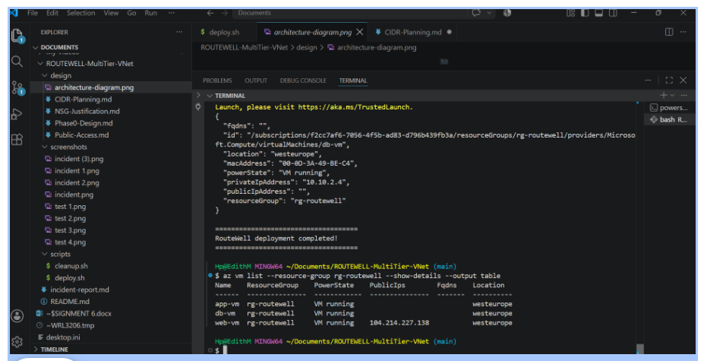
Figure 8.1 — VS Code showing the completed deploy.sh run in the integrated terminal, next to the repository's design/ and screenshots/ folders and the final az vm list summary table confirming all three VMs are running.

8.5 Verifying and Recording IP Addresses
az network public-ip show --resource-group "$RG" --name web-pip --query ipAddress -o tsv
az network nic show --resource-group "$RG" --name app-nic --query "ipConfigurations[0].privateIPAddress" -o tsv
az network nic show --resource-group "$RG" --name db-nic --query "ipConfigurations[0].privateIPAddress" -o tsv
The --query option lets me pull out one specific piece of information from Azure's much larger JSON response, instead of reading the whole thing manually. -o tsv formats that one piece of information as plain text. I used these commands to record the exact IP addresses I would need for every SSH command and connectivity test afterward.
VM | Private IP | Public IP
web-vm | 10.10.0.4 | Yes — reachable from the internet
app-vm | 10.10.1.4 | None — private only
db-vm | 10.10.2.4 | None — private only
Seeing an empty public IP field for app-vm and db-vm was, itself, a form of verification: it confirmed the design decision from Phase 7.9 was actually applied correctly, not just planned on paper.

8.6 Why Each VM Belongs in Its Subnet
Web VM belongs in the Web subnet because it is the only component RouteWell's brief requires to face the public internet. App VM belongs in the App subnet because it needs to be reachable by Web (for the application to function) but must never be reachable by the public internet directly. Database VM belongs in the Database subnet because it holds the most sensitive data in the whole system and must only ever be reached by the one component that legitimately needs it — the App tier.

Phase 9 — Connectivity Testing
Building the network is not enough — the brief specifically requires proof that the security design actually works, not just that it was configured correctly on paper. I used a small tool called nc (short for netcat) to test whether a specific port on a specific machine was reachable or not, without needing a real running application.

9.1 Preparing to Test
Because App VM and Database VM have no public IP address, I could not connect to them directly from my own computer. Instead, I had to "jump" through Web VM first, using a feature of SSH called ProxyJump (the -J option), which uses one SSH connection as a stepping stone to reach a second, private machine. For the jump to carry my identity all the way through, I first loaded my SSH key into a small background helper program called ssh-agent:
eval "$(ssh-agent -s)"
ssh-add ~/.ssh/id_rsa
ssh-agent holds my private key in memory for the terminal session, so I am not asked to unlock it again on every hop of a multi-step SSH connection.

9.2 Installing Test Tools
I confirmed netcat was available on all three VMs (it turned out to already be included with Ubuntu Server 22.04 by default), installed and started PostgreSQL — the database engine — on Database VM so that port 5432 actually had something listening on it to test against, and started a temporary dummy listener on port 8080 on App VM, so that Test 1 had a real, live target to connect to instead of just an open, empty port.

9.3 Test 1 — Web → App
ssh -i ~/.ssh/id_rsa azureuser@$WEB_IP "nc -zv -w 5 $APP_IP 8080"
This command logs into Web VM, and from inside that machine, tries to open a connection to App VM's private IP address on port 8080. The -z option tells nc to just test the connection and then close it immediately, without sending any data. -v means verbose, so it prints a clear result. -w 5 sets a five-second timeout, so the command does not hang forever if the connection is blocked.
Expected result: success, because my Allow-App-From-Web rule specifically permits this.
Actual result: Connection to 10.10.1.4 8080 port [tcp/http-alt] succeeded! — matching the expected result exactly.
[Insert screenshot here] Terminal output showing Test 1 succeeding.

9.4 Test 2 — App → Database
ssh -A -J azureuser@$WEB_IP -i ~/.ssh/id_rsa azureuser@$APP_IP "nc -zv -w 5 $DB_IP 5432"
This uses the -J (ProxyJump) option to first connect to Web VM, and from there, hop into App VM. Once inside App VM, it runs the same nc test against Database VM's private IP address on port 5432. The -A option forwards my loaded SSH key through the jump, so the second hop can also authenticate successfully.
Expected result: success, because my Allow-DB-From-App rule specifically permits this.
Actual result (after a fix described in Phase 12): Connection to 10.10.2.4 5432 port [tcp/postgresql] succeeded! — matching the expected result.
[Insert screenshot here] Terminal output showing Test 2 succeeding.

9.5 Test 3 — Web → Database (Must Be Blocked)
ssh -i ~/.ssh/id_rsa azureuser@$WEB_IP "nc -zv -w 5 $DB_IP 5432"
This test logs into Web VM, and tries to reach Database VM's port 5432 directly, skipping the App tier entirely. This is the single most important test in the whole project, because it directly proves (or disproves) RouteWell's core compliance requirement.
Expected result: blocked — the connection should time out, because no rule in my design allows Web to reach Database.
Actual result, final: nc: connect to 10.10.2.4 port 5432 (tcp) timed out: Operation now in progress — the connection correctly failed.
Warning: The very first time I ran this test, it unexpectedly succeeded instead of failing. I explain exactly why, and how I fixed it, in Phase 12 — it is one of the most important lessons from this entire project.
[Insert screenshot here] Terminal output showing Test 3 blocked (timing out) after the fix.

9.6 Internet → Web Allowed
I confirmed this indirectly: Web VM's public IP address, combined with the Allow-HTTP-HTTPS rule sourced from Internet, is what makes the dispatch web app reachable from any device on the public internet, not just from my own computer.

9.7 Internet → Database Blocked
This is guaranteed by design, not just by a firewall rule: Database VM has no public IP address at all. There is no route from the public internet to it whatsoever, regardless of any NSG rule, which is a stronger guarantee than a firewall rule alone would be.

9.8 Why Each Result Matters
Test 1 proves the application can actually function — the web tier can reach its backend. Test 2 proves the application can actually store and retrieve data — the app tier can reach the database. Test 3 proves the compliance requirement is genuinely enforced, not just assumed. Together, these three results are the evidence that turns "I designed a secure network" from a claim into a demonstrated fact.

Phase 10 — Automation
The brief required a Bash script that automates the entire deployment end-to-end, so that the whole network could be rebuilt from nothing with one command. I built scripts/deploy.sh for this purpose. Below, I explain the script line by line, in the order it actually runs.

10.1 Why Automation Is Better Than Manual Deployment
- Consistency — a script runs the exact same commands, in the exact same order, every time, with no risk of a typo or a forgotten step that a human clicking through the Portal might make.
- Speed — the entire network can be rebuilt in a few minutes instead of manually recreating dozens of resources by hand.
- Documentation — the script itself is a precise, unambiguous record of exactly what was built.
- Disaster recovery — if I ever need to delete everything and start again (which, as documented in Phase 12, I actually did more than once), automation turns a stressful rebuild into a single command.

10.2 The Script, Explained Line by Line
#!/usr/bin/env bash
This is called a shebang line. It tells the operating system which program should be used to run this file — in this case, the bash shell.
set -e
This tells Bash to stop the entire script immediately if any single command inside it fails, instead of carrying on and potentially trying to build resources on top of a step that never actually succeeded.
ADMIN_IP=$(curl -s -4 ifconfig.me)
As explained in Phase 7.1, this fetches my current public IP address and stores it for use in the SSH firewall rules further down the script.
The next block sets every variable — region, resource group name, VNet name, address ranges, and subnet names — exactly as explained in Phase 7.2, so the rest of the script never contains a single hard-coded value.
The script then runs, in strict order: az group create, az network vnet create (with the Web subnet included), az network vnet subnet create (twice, for App and Database), az network nsg create (three times, one per tier), az network vnet subnet update (three times, attaching each NSG to its subnet), az network nsg rule create (nine times — I explain why it is nine, not six, below), az network public-ip create, az network nic create (three times), and finally az vm create (three times). Every one of these commands is identical to the version I explained individually in Phases 7 and 8 — the script simply runs them all, back to back, without me needing to type each one by hand.

10.2.1 Why Nine NSG Rules, Not Six
Phase 4 documents the six rules I originally designed on paper — two per tier. The final version of deploy.sh actually creates nine rules: the same six, plus one additional Deny-Other-VNet-Inbound rule on each of app-nsg and db-nsg. I added these three extra rules after discovering, during testing, that Azure's default AllowVnetInBound rule would otherwise let any subnet reach any other subnet, silently overriding the least-privilege design I thought I had already finished. I explain exactly how I found this, and why the fix works, in Phase 12, Problem 9. I am noting the discrepancy here deliberately, rather than quietly rewriting Phase 4, because the gap between my original design and my final, tested design is itself part of the honest story of this project.
Here is the Database NSG rules block exactly as it appears in my final deploy.sh, shown in full because it is the block that fixes the most serious issue I found in this whole project:
echo "Creating Database NSG Rules..."
# Allow App tier to reach PostgreSQL
az network nsg rule create \
--resource-group "$RG" \
--nsg-name db-nsg \
--name Allow-App-To-DB \
--priority 100 \
--direction Inbound \
--access Allow \
--protocol Tcp \
--source-address-prefix 10.10.1.0/26 \
--source-port-range "*" \
--destination-port-range 5432
# Allow SSH only from the App subnet (jump-host chain)
az network nsg rule create \
--resource-group "$RG" \
--nsg-name db-nsg \
--name Allow-SSH \
--priority 110 \
--direction Inbound \
--access Allow \
--protocol Tcp \
--source-address-prefix 10.10.1.0/26 \
--source-port-range "*" \
--destination-port-range 22
# Block all other traffic from the Virtual Network
az network nsg rule create \
--resource-group "$RG" \
--nsg-name db-nsg \
--name Deny-Other-VNet-Inbound \
--priority 200 \
--direction Inbound \
--access Deny \
--protocol "*" \
--source-address-prefix VirtualNetwork \
--source-port-range "*" \
--destination-address-prefix "*" \
--destination-port-range "*"
Why priority 200 specifically: My two Allow rules sit at priority 100 and 110 — both lower numbers than 200, so App-subnet traffic matches one of those first and is allowed, before Azure ever checks the Deny-Other-VNet-Inbound rule. Any other VNet-sourced traffic, such as a request from the Web subnet, matches neither of my Allow rules, falls through to this Deny rule at 200, and is blocked — all before it would otherwise have reached Azure's own default AllowVnetInBound rule at 65000.
I added the identical Deny-Other-VNet-Inbound rule to app-nsg as well, for design consistency, even though nothing in my testing actively exercises that specific path.
unset MSYS_NO_PATHCONV
I added this line partway through the project, right before the VM creation commands, after discovering that the path-conversion fix from Phase 6.7 was itself causing my SSH key file path to fail. This turns the fix back off just before it would have caused a problem. I explain this discovery fully in Phase 12.

10.3 cleanup.sh, Explained
#!/usr/bin/env bash
set -euo pipefail
RG="rg-routewell"
echo "This will delete resource group '$RG' and everything in it."
read -p "Type the resource group name to confirm: " CONFIRM
[ "$CONFIRM" = "$RG" ] || { echo "Confirmation didn't match. Aborting."; exit 1; }
az group delete --name "$RG" --yes
set -euo pipefail is a stricter version of set -e: -u also stops the script if I reference a variable that was never set (catching typos), and -o pipefail makes a chain of piped commands fail if any part of the chain fails, not just the last one. read -p pauses the script and asks me to type something, storing my answer in the CONFIRM variable. The line after it compares what I typed against the real resource group name, and stops the script if they do not match exactly — a safety check so that running this script by accident does not immediately delete my entire project. Finally, az group delete --name "$RG" --yes deletes the resource group and, with it, every single resource inside it — the VNet, all three subnets, all three NSGs and their rules, all three NICs, the public IP, and all three virtual machines — in one single action.

Phase 11 — Git and GitHub

11.1 git clone
git clone https://github.com/<my-username>/routewell-vnet-capstone.git
This downloads a full copy of my empty GitHub repository, including its hidden .git folder that tracks history, onto my own computer, so I can start adding files to it.

11.2 git add
git add .
This tells Git "prepare every changed or new file in this folder to be included in the next save point." The single dot means "everything in the current folder and its subfolders." This step does not save anything permanently yet — it only stages the changes, meaning it marks them as ready.

11.3 git commit
git commit -m "Initial repo structure for RouteWell VNet capstone"
This creates an actual, permanent save point (called a commit) out of everything I staged with git add. The -m option lets me attach a short message explaining what changed in this save point, which becomes part of the permanent project history.

11.4 git push
git push -u origin main
Up to this point, every commit only existed on my own computer. git push uploads my commits to GitHub, making them visible in my online repository. origin is the name Git uses by default for "the remote copy of this repository on GitHub." main is the name of my primary branch — a branch is an independent line of history, and main is the default one every new repository starts with. The -u option tells Git to remember this pairing, so future pushes can simply be git push with no extra options.

11.5 Branch Creation
For this project, I worked entirely on the main branch, since it is a solo capstone project with no need to isolate experimental work from a stable version. In a team project, I would create a separate branch for new work with git checkout -b <branch-name>, so that unfinished changes never affect the main branch until they are reviewed and merged.

11.6 README
My README.md file is the front page of my repository — the first thing anyone (including my grader) sees when they open it on GitHub. It documents an overview of the project, the architecture, prerequisites, how to run deploy.sh, a full mapping of every NSG rule to its justification, a summary of the connectivity test results, a summary of the incident, and how to run cleanup.sh.

11.6.1 Evidence — The Pushed Repository on GitHub
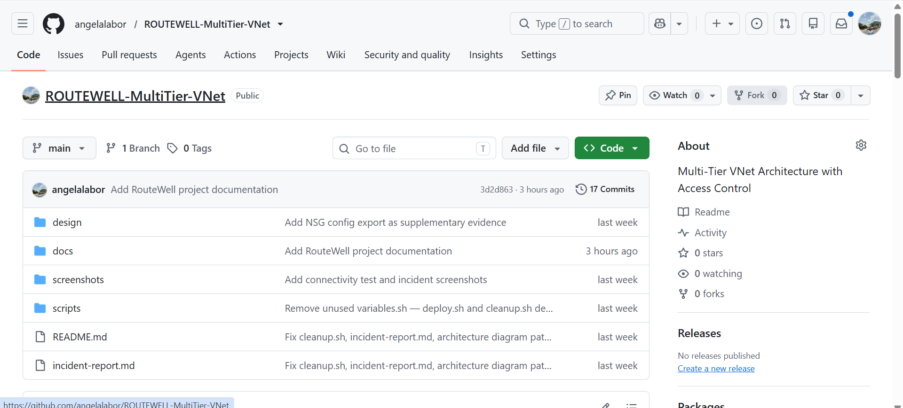
Figure 11.1 — The ROUTEWELL-MultiTier-VNet repository on GitHub, showing the design/, docs/, screenshots/, and scripts/ folders, README.md and incident-report.md at the root, and the commit history confirming everything was actually pushed.

11.7 Folder Structure
routewell-vnet-capstone/
├── design/
│ ├── phase0-worksheet.md
│ └── architecture-diagram.png
├── scripts/
│ ├── deploy.sh
│ └── cleanup.sh
├── screenshots/
├── incident-report.md
├── README.md
└── .gitignore
I organised the repository this way so that design documents, executable scripts, and evidence (screenshots) are each easy to find in their own dedicated folder, rather than everything sitting loose in one place.

11.8 .gitignore
Environment and secret files
.env
.env.*
*.env

# SSH private keys
id_rsa
id_rsa.pem
*.pem

# Azure local configuration
.azure/

# Operating system files
.DS_Store
Thumbs.db

# VS Code settings
.vscode/

# Temporary and log files
*.tmp
*.log

A .gitignore file lists files and patterns that Git should never track or upload, even with git add . I used this specifically to make sure my private SSH key could never accidentally end up in my public GitHub repository, which would be a serious security mistake.

11.9 Screenshots
I saved every connectivity test screenshot from Phase 9, and the failure/fix screenshots from Phase 12, into the screenshots/ folder, and referenced them by name inside my README so a grader can match each proof to the specific test it demonstrates.

Phase 12 — Problems Encountered
This section is a completely honest record of every real problem I ran into while building this project, in the order I encountered them. I am including this because working through real errors, not just following a perfect script, is what this capstone is actually testing.

Problem 1 — Missing Line Continuations in My NSG Rule Commands
What happened: My very first draft of deploy.sh had three NSG rule commands (for HTTP, HTTPS, and SSH on the Web tier) where I forgot the backslash (\) at the end of one line inside each command.
How I noticed it: The script stopped running immediately, with Bash trying to run --source-port-range as if it were its own separate command, which does not exist.
What I investigated: I re-read the script line by line and compared it against a working command elsewhere in the same file.
Root cause: In Bash, a backslash at the end of a line tells the shell "this command is not finished yet, continue reading the next line as part of it." Without that backslash, Bash assumed the command had ended, and tried to run the next line as a brand-new, separate command.
How I fixed it: I added the missing backslash after every --source-address-prefix line that was missing one.
How I verified the fix: I re-ran the script and confirmed all three rules were created successfully with a clean JSON response for each.
Lesson learned: A missing line-continuation character is easy to miss visually but stops an entire script dead. I now proofread multi-line commands more carefully, and I know to check for this specific mistake first whenever a script fails right after a multi-line command.

Problem 2 — Web Traffic Rule Scoped to My Own IP Instead of the Internet
What happened: I had accidentally set the source of my HTTP/HTTPS rule to my own admin IP address instead of the special value Internet.
How I noticed it: On review, I noticed this rule would only ever let me, personally, reach the website — nobody else on the internet could reach it, which directly contradicts the brief's core requirement that the dispatch app be publicly reachable.
What I investigated: I compared my rule against the brief's stated requirement and against my own Phase 4 design table.
Root cause: I had copy-pasted my SSH rule's structure to create the HTTP/HTTPS rule, and forgot to change the source address value from my IP to Internet.
How I fixed it: I changed --source-address-prefix on that rule from "${ADMIN_IP}/32" to "Internet".
How I verified the fix: I confirmed the rule's source now correctly showed "sourceAddressPrefix": "Internet" in Azure's response.
Lesson learned: Copy-pasting a similar command is efficient, but every value inside it needs to be re-checked individually, especially the source address, since getting this wrong silently breaks the entire purpose of the rule without causing any error message at all.

Problem 3 — SSH Key File Not Found
What happened: When I first tried to create web-vm, Azure returned the error: "An RSA key file or key value must be supplied to SSH Key Value."
How I noticed it: The error appeared immediately when the az vm create command ran, before any VM was actually created.
What I investigated: I checked whether the SSH key file actually existed on my computer, using ls -la ~/.ssh/.
Root cause: I had never actually run ssh-keygen to generate a key pair — I had assumed one already existed from an earlier, unrelated project.
How I fixed it: I ran ssh-keygen -t rsa -b 4096 to generate a fresh key pair, then confirmed the new public key file's contents with cat ~/.ssh/id_rsa.pub.
How I verified the fix: I re-ran the same az vm create command and it succeeded.
Lesson learned: Never assume a prerequisite file exists — verify it directly before relying on it in a command that will otherwise fail with a somewhat generic error message.

Problem 4 — The Same SSH Key Error Returned, Even Though the Key Existed
What happened: Later, after confirming my SSH key genuinely existed and was valid, the exact same "RSA key file must be supplied" error came back — but only when running the command from inside my deploy.sh script, not when I ran the identical command by hand.
How I noticed it: I compared two runs side by side: the manual command succeeded, the scripted version failed, with nothing else different.
What I investigated: I looked at every setting active in each terminal session and found only one difference: MSYS_NO_PATHCONV=1 (from Phase 6.7) was set for the whole duration of the script, but was not set in my manual test.
Root cause: MSYS_NO_PATHCONV=1 stops Git Bash from converting Unix-style paths, like ~/.ssh/id_rsa.pub, into a Windows-style path that the Azure CLI program (which is a Windows program under the hood) can actually open. With the setting active for the whole script, it broke the SSH key path even though it was needed earlier in the same script to protect my CIDR ranges.
How I fixed it: I added the line unset MSYS_NO_PATHCONV inside deploy.sh, placed right before the VM creation commands, so the fix is active only where it is needed (the networking commands) and turned off before it can cause harm (the SSH key path).
How I verified the fix: I re-ran the full script from a freshly deleted resource group, and it built the entire environment, including all three VMs, in one uninterrupted run.
Lesson learned: A fix for one problem can quietly cause a different problem later in the same script. The solution was not to remove the fix, but to scope it narrowly, to only the part of the script that actually needed it.

Problem 5 — IPv6 Address Broke My SSH Firewall Rule
What happened: One re-run of the script returned the error "Security rule ... has invalid Address prefix. Value provided: 2605:59c1:1940:..." — a long address that did not look like a normal IP address.
How I noticed it: The error appeared while creating the Allow-SSH rule specifically, right after the Allow-HTTP-HTTPS rule had succeeded normally.
What I investigated: I recognised the address format as IPv6 (a newer, longer style of IP address) rather than the IPv4 style (like 98.97.79.54) I expected.
Root cause: My command curl -s ifconfig.me sometimes returns an IPv6 address instead of an IPv4 one, depending on which type of connection my home network prefers at that moment. My script was appending /32 to whatever it got back, but /32 is only a valid mask for IPv4 addresses — an IPv6 address needs /128 instead, and Azure rejected the mismatched combination outright.
How I fixed it: I changed the command to curl -s -4 ifconfig.me, adding the -4 option to force an IPv4-only request every time, so the returned address is always compatible with the /32 suffix my script adds.
How I verified the fix: I re-ran the script and confirmed ADMIN_IP now printed a normal IPv4 address, and the SSH rule was created successfully with no error.
Lesson learned: A command that appears to work correctly most of the time can still fail unpredictably depending on outside conditions, like which network a computer happens to be using that day. Forcing a specific, predictable behaviour (IPv4-only) removed that uncertainty completely.

Problem 6 — Requested VM Size Not Available in My Region
What happened: When creating web-vm with --size Standard_B1s, Azure returned: "(SkuNotAvailable) The requested VM size ... is currently not available in location 'westeurope'."
How I noticed it: The error appeared immediately after VM creation started, quoting the specific size I had requested.
What I investigated: I tried a closely related size, Standard_B1ms, and received the identical SkuNotAvailable error for that size too.
Root cause: This was a genuine, temporary capacity shortage on Azure's side — the specific physical hardware needed to run that VM size simply had no free capacity in the westeurope region at that moment. This is unrelated to my account, my script, or my design; it happens with smaller VM sizes in busy regions from time to time.
How I fixed it: I ran az vm list-skus --location westeurope --size Standard_B --output table to see every B-series size actually available to my subscription in that region, and confirmed the original B-series family (which includes B1s, B1ms, B2s) had no listed restriction, even though capacity for those two specific sizes was unavailable at that moment.
How I verified the fix: This investigation led directly into Problem 7, described next, once I discovered a separate quota issue affecting the newer B-series sizes.
Lesson learned: Not every deployment error is caused by something I did wrong — sometimes the cloud platform itself simply does not have available hardware for a specific request at a specific moment, and the fix is to choose a genuinely different option, not to keep retrying the exact same one.

Problem 7 — Zero Quota for an Entire VM Size Family
What happened: I tried the newer Standard_B1ms and Standard_B2s (v2 generation) sizes, and received a different error this time: "(QuotaExceeded) ... Current Limit: 0, Current Usage: 0, Additional Required: 2."
How I noticed it: The error explicitly stated my subscription's current limit for this VM family was zero, not just unavailable.
What I investigated: I ran az vm list-usage --location westeurope --output table, which lists every VM size family and shows exactly how many I am allowed to use versus how many I am currently using.
Root cause: My Azure subscription (a free or trial-tier subscription) had a hard quota of zero cores approved for the entire Basv2/Bsv2/Bpsv2 family of VM sizes in this region — not a capacity shortage this time, but a genuine permission limit tied to my specific subscription type. Meanwhile, the output showed my subscription did have a real, usable quota of 10 cores for the DSv3 family, which includes Standard_D2s_v3.
How I fixed it: I switched all three VMs from the B-series to Standard_D2s_v3, a size confirmed to have real, available quota on my subscription.
How I verified the fix: I deleted the partially-built resource group with az group delete, and re-ran the full deploy.sh script from a completely clean state; all three VMs were created successfully on the first attempt this time.
Lesson learned: A subscription's allowed VM sizes are not the same everywhere, and can differ from region to region and from account type to account type. Rather than guessing size names one at a time, checking the account's actual usage and quota limits directly is a faster, more reliable way to find a size that will genuinely work.

Problem 8 — Unverified Ubuntu 24.04 Image URN Failed
What happened: I tried switching my VM image from Ubuntu 22.04 to a newer Ubuntu 24.04 URN I had guessed at, and received "(NotFound) Artifact: VMImage was not found."
How I noticed it: The command failed immediately, before any VM resources were touched.
What I investigated: I checked the exact URN string I had written, and separately queried Azure for every real 24.04 image it actually publishes with az vm image list --publisher Canonical --sku 24_04 --all --output table.
Root cause: I had typed a URN for Ubuntu 24.04 from memory, without confirming it against Azure's real catalogue of published images first. The offer and SKU names I guessed simply did not exist under those exact names.
How I fixed it: Rather than keep guessing at 24.04 URNs, I returned to the Ubuntu 22.04 URN I had already explicitly verified earlier with az vm image show, which I knew for certain was valid in my region: Canonical:0001-com-ubuntu-server-jammy:22_04-lts-gen2:latest.
How I verified the fix: I confirmed this URN with az vm image show before using it again, and VM creation succeeded using it.
Lesson learned: Never type a resource identifier like an image URN from memory and assume it is correct — Azure's own lookup commands (az vm image show, az vm image list) exist specifically to confirm a value is real before depending on it in a deployment.

Problem 9 — Web-to-Database Traffic Was Not Actually Blocked
What happened: During my first full run of connectivity Test 3 (Web → Database, which is required to be blocked), the connection unexpectedly succeeded instead of timing out.
How I noticed it: I ran the exact same nc command I had used for the successful Test 1 and Test 2, expecting a timeout, and instead saw "Connection to 10.10.2.4 5432 port [tcp/postgresql] succeeded!" — the opposite of what my design should have produced.
What I investigated: I reviewed my db-nsg rules and confirmed my explicit rules only ever mentioned the App subnet as an allowed source, never the Web subnet. This meant my explicit rules were not the cause of the leak, so something else in Azure's own default configuration had to be responsible.
Root cause: Every Azure NSG automatically includes a set of default rules that cannot be deleted, and one of them, called AllowVnetInBound, permits traffic from any subnet inside the VNet to reach any other subnet inside the VNet, at priority 65000 — which is checked before the very last default rule, DenyAllInBound, at priority 65500. My own explicit rules only matched App-subnet traffic, so Web-subnet traffic simply skipped past my rules (because they did not match) and was picked up and allowed by this earlier, broader default rule instead, before it ever reached the final deny.
How I fixed it: I added a new explicit rule to db-nsg named Deny-Other-VNet-Inbound, set to Deny access, sourced from VirtualNetwork (meaning any subnet in the VNet), at priority 200 — a number lower than Azure's default AllowVnetInBound (65000), so my new deny rule is checked and applied first for any VNet-sourced traffic that did not already match one of my earlier, more specific allow rules at priority 100 or 110. I added the identical rule to app-nsg as well, for design consistency, even though nothing was actively testing that particular path.
How I verified the fix: I re-ran Test 3 and confirmed the connection now correctly timed out. I then re-ran Test 2 (App → Database) to make absolutely sure the new deny rule had not accidentally broken the legitimate path, and confirmed it still succeeded, because App-subnet traffic matches my own Allow-DB-From-App rule at priority 100, before it ever reaches the new deny rule at priority 200.
Lesson learned: This was the single most important lesson of the entire project. Designing a set of allow rules is not, by itself, enough to guarantee that everything else is blocked — I had to actually understand and account for Azure's own default rules, which exist whether I put them there or not. It also proved why actual connectivity testing (Phase 9), not just reading a list of rules on paper, is essential: reading my rule list alone would never have revealed this gap, because none of my own rules were technically wrong. Only running the real test caught it.

Problem 10 — My Live SSH Rule Still Pointed at My Admin IP Instead of the Jump-Host Subnet
What happened: While reviewing my actually-deployed NSG rules against my design worksheet, I noticed that app-nsg's Allow-SSH rule was still sourced from my own admin IP address, even though App VM has no public IP address and my admin IP can never physically reach it.
How I noticed it: I compared my live rule list, retrieved with az network nsg rule list, against what my own Public-Access.md worksheet described — a jump-host chain where SSH to App arrives from the Web subnet, not from my own computer directly. The two did not match.
What I investigated: I checked whether this rule had ever actually been exercised successfully. It had — but only because, at the time I ran my very first SSH jump-host commands, my Deny-Other-VNet-Inbound rule from Problem 9 did not exist yet, so Web-to-App SSH traffic was quietly passing through Azure's default AllowVnetInBound rule by accident, the same underlying gap that caused Problem 9 in the first place.
Root cause: The rule had never been corrected after I first designed the jump-host access pattern. Once I added Deny-Other-VNet-Inbound to app-nsg to close the Problem 9 gap, that same rule would also have silently closed off my own accidental Web-to-App SSH path, since Web-subnet-sourced traffic no longer matched any explicit allow rule on app-nsg.
How I fixed it: I updated the rule directly with az network nsg rule update, changing its source-address-prefix from my admin IP to the Web subnet's CIDR range (10.10.0.0/27), and made the same correction inside deploy.sh itself so a fresh deployment would build the correct rule from the start rather than requiring a manual patch afterward.
How I verified the fix: I re-ran my SSH jump-host command from my own computer, through Web VM, into App VM, and confirmed it still connected successfully after the change — proving the fix matched what my design worksheet always intended, not just what happened to work by accident before.
Lesson learned: A rule that appears to work is not the same as a rule that works for the reason I think it does. This rule had been quietly succeeding for the wrong reason the entire time, and only stopped being an accident once I closed the Problem 9 gap. Reconciling my live configuration against my own written design, rather than trusting that anything currently working is therefore correct, is what caught this.

Problem 11 — Two Repository Files Were Accidentally Overwritten With the Wrong Content
What happened: While finishing my repository, I discovered that scripts/cleanup.sh contained a chunk of my project's written overview text instead of the actual cleanup script, and separately that incident-report.md contained its own correct content but with entire paragraphs duplicated and reordered out of sequence.
How I noticed it: Running scripts/cleanup.sh produced immediate Bash syntax errors, including "command not found" on plain English words — a clear sign the file did not contain a script at all. Separately, reading back incident-report.md, I noticed the Symptom section appearing in the middle of the file instead of the top, and a sentence cutting off mid-word before jumping into a different section's heading.
What I investigated: I ran cat on both files directly to see their real, current contents rather than assuming what I had originally written was still there.
Root cause: At some point while working across several open files and repeated copy-paste actions, content intended for one file was pasted into the wrong one, and in the incident report's case, likely pasted a second time on top of an already-correct version, duplicating and scrambling its section order.
How I fixed it: For each affected file, I did not try to manually patch the scrambled content. I fully overwrote each file with a clean, complete, correctly-ordered version of its intended content, using a single command that replaces the entire file at once, which avoids the risk of a partial edit leaving old scrambled text mixed in with the correction.
How I verified the fix: I ran cat on both files again after the fix and read them start to finish to confirm the content was complete, correctly ordered, and contained no leftover fragments from the previous mistake, before committing the fix.
Lesson learned: When copy-pasting the same kind of content into several similarly-purposed files in one working session, it is easy to lose track of which file is actually open. The reliable fix is not to trust a quick visual skim, but to read a file's real, current content in full before assuming a previous edit is still intact — especially right before a final commit.

Phase 13 — Final Architecture Review

13.1 Does the Solution Meet Every Client Requirement?
Requirement | Met? | Evidence
Web app reachable from the internet | Yes | Web VM has a Standard public IP and an Allow rule sourced from Internet on ports 80/443.
Database never reachable from the internet | Yes | Database VM has no public IP address at all, and is additionally protected by explicit NSG rules.
Minimum necessary ports only, no allow-all shortcuts | Yes | Nine explicit rules exist across all three NSGs — the original six from my Phase 0 design, plus three Deny-Other-VNet-Inbound rules added after Phase 12, Problem 9. Every rule maps to a specific, stated need; none are a broad allow-all shortcut.
Lean, cost-effective resource footprint | Partially — documented deviation | Originally planned Standard_B1s; switched to Standard_D2s_v3 due to a genuine subscription quota limit on smaller sizes, documented fully in Phase 12, Problem 7.
Room for six-month growth | Yes | App subnet sized at /26 specifically to fit the projected doubling of app-tier hosts.

13.2 Security
The database is protected by two independent layers: it has no public IP address at all (removing any direct internet route), and its NSG only allows traffic from the App subnet specifically. During testing, I discovered and closed a real gap where Azure's own default rules would have allowed the Web tier to bypass my intended restrictions — finding and fixing that gap is itself evidence that the security design was properly tested, not just assumed correct.

13.3 Cost Effectiveness
The design uses exactly three virtual machines, the smallest number that still satisfies genuine tier separation, one Standard public IP (the minimum needed to expose the one tier that must be public), and no Load Balancer, Application Gateway, or Azure Bastion, each of which would have added ongoing cost not justified by the current single-VM-per-tier scale of this project.

13.4 Future Scalability
The VNet's /16 address space leaves the vast majority of possible address ranges completely unused, meaning new tiers or services can be added later without redesigning the existing network. The App subnet was specifically sized using the six-month growth projection from the brief, not just today's numbers.

13.5 Network Segmentation
Each tier lives in its own subnet with its own dedicated NSG, meaning a security problem on one tier does not automatically grant access to another tier — the exact opposite of the flat-network problem described in RouteWell's original scenario.

13.6 Least Privilege
Least privilege means giving every component exactly the access it needs, and nothing more. Every one of my six NSG rules exists for one specific, named reason, and I can state exactly what breaks if any single one of them is removed — which is precisely the least-privilege standard the brief's Phase 0 worksheet required me to justify.

13.7 Availability
This project uses a single VM per tier, with no redundancy or automatic failover. This is an acceptable trade-off for a lean, cost-constrained proof-of-concept, but it is a real limitation: if any one VM fails, that entire tier goes down. A production-grade version of this design would add a second VM per tier behind a Load Balancer, at additional cost.

13.8 Possible Improvements
- Add a second VM per tier with an Azure Load Balancer, to remove the single-point-of-failure risk described above.
- Replace open SSH access with Azure Bastion, removing port 22 from the internet-facing NSG entirely, once budget allows.
- Automate the connectivity tests themselves as part of deploy.sh, so a broken rule (like the one found in Phase 12, Problem 9) is caught immediately after every deployment, not only when someone remembers to test manually.
- Move the SSH private key handling into a properly managed secrets solution instead of a local file, for a real production environment.

Phase 14 — Conclusion
This project took me from a blank Azure subscription to a fully working, tested, and documented three-tier network with real, enforced security boundaries. Along the way, I made real mistakes, hit real Azure platform limitations, and found a real, subtle gap in my own security design — and I fixed every one of them myself, using the platform's own diagnostic tools rather than guesswork.

14.1 Azure Skills Gained
I can now confidently create and connect Resource Groups, Virtual Networks, Subnets, Network Security Groups, Public IP addresses, Network Interfaces, and Virtual Machines entirely from the command line, and I know how to look up real, valid image URNs, VM sizes, and account quota limits instead of guessing at them.

14.2 Networking Skills Gained
I learned how to calculate CIDR ranges by hand, accounting for Azure's reserved addresses, based on both current and projected future host counts. I also learned, in a very concrete and memorable way, that a cloud platform's default firewall behaviour can silently undermine a design that looks correct on paper, and that only real testing — not just reading a rule list — can catch that.

14.3 Security Lessons
The most important security lesson from this project is that access control needs to be verified, not assumed. My explicit NSG rules were all individually correct, and yet the network was still not fully secure until I tested it and found the gap left open by Azure's own default AllowVnetInBound rule.

14.4 Automation Lessons
I learned that a helpful setting in one part of a script (like MSYS_NO_PATHCONV=1 fixing my CIDR ranges) can quietly break something completely different later in the same script (my SSH key path), and that the fix is often to scope a setting narrowly to exactly where it is needed, rather than leaving it active for an entire script.

14.5 GitHub Lessons
I learned the discipline of keeping secrets like SSH private keys out of version control entirely, using a .gitignore file, and I practiced the basic Git workflow of stage, commit, and push as a repeatable habit rather than a one-time setup step.

14.6 Real-World Value of This Project
This project mirrors a genuinely common real-world scenario: a company outgrowing a flat, insecure network and needing it professionally redesigned around least-privilege principles. The skills I practiced here — CIDR planning, least-access firewall design, infrastructure automation, and rigorous testing rather than assumption — are directly transferable to real cloud engineering and DevOps work.

14.7 Future Improvements I Would Make
Beyond the technical improvements listed in Phase 13.8, the biggest process improvement I would make next time is to run my full connectivity test suite immediately after every deployment, by default, rather than treating it as a separate manual step — because the most serious issue I found in this entire project (Phase 12, Problem 9) would have gone completely unnoticed without it.

14.8 Final Repository State and Teardown
Before submitting, I did a full reconciliation pass across every file in my repository, reading each one's real, current content against what I had actually built and tested on Azure — the process that caught Problems 10 and 11 in Phase 12. My final repository contains: design/ (the four Phase 0 worksheet documents, reformatted to match the brief's exact requested CIDR table columns, plus the architecture diagram), scripts/deploy.sh and scripts/cleanup.sh (both matching my live, tested configuration exactly, including the corrected jump-host SSH rules on app-nsg and db-nsg), screenshots/ (all seven required connectivity and incident images), incident-report.md, and README.md. I removed an unused variables.sh file that neither script actually referenced, since an unused file with resource names that did not match my real deployment was more likely to mislead a reader than help one. Once every file was verified and pushed, I ran scripts/cleanup.sh to tear down the live Azure environment and stop incurring cost, since every deliverable the brief requires — the repository itself, the design worksheet, the screenshots, and the incident report — exists independently of whether the environment is still running.

— Full Script Listings
The complete, final contents of both deployment scripts are reproduced here in full, exactly as they exist in the repository at scripts/deploy.sh and scripts/cleanup.sh, so the whole build and teardown process can be read start to finish without needing to open GitHub separately.

— scripts/deploy.sh
#!/usr/bin/env bash
export MSYS_NO_PATHCONV=1
set -e
echo "Getting your public IP..."
ADMIN_IP=$(curl -s -4 ifconfig.me)
echo "Admin IP: $ADMIN_IP"
# Variables
LOCATION="westeurope"
RG="rg-routewell"
VNET="vnet-routewell"
ADDRESS_SPACE="10.10.0.0/16"
WEB_SUBNET="web-subnet"
WEB_PREFIX="10.10.0.0/27"
APP_SUBNET="app-subnet"
APP_PREFIX="10.10.1.0/26"
DB_SUBNET="db-subnet"
DB_PREFIX="10.10.2.0/28"
echo "Creating Resource Group..."
az group create --name "$RG" --location "$LOCATION"
echo "Creating Virtual Network..."
az network vnet create --resource-group "$RG" --name "$VNET" \
--address-prefixes "$ADDRESS_SPACE"
echo "Creating Web Subnet..."
az network vnet subnet create --resource-group "$RG" --vnet-name "$VNET" \
--name "$WEB_SUBNET" --address-prefixes "$WEB_PREFIX"
echo "Creating App Subnet..."
az network vnet subnet create --resource-group "$RG" --vnet-name "$VNET" \
--name "$APP_SUBNET" --address-prefixes "$APP_PREFIX"
echo "Creating Database Subnet..."
az network vnet subnet create --resource-group "$RG" --vnet-name "$VNET" \
--name "$DB_SUBNET" --address-prefixes "$DB_PREFIX"
az network vnet subnet list --resource-group "$RG" --vnet-name "$VNET" --output table
echo "Creating Network Security Groups..."
az network nsg create --resource-group "$RG" --name web-nsg --location "$LOCATION"
az network nsg create --resource-group "$RG" --name app-nsg --location "$LOCATION"
az network nsg create --resource-group "$RG" --name db-nsg --location "$LOCATION"
echo "Associating NSGs with subnets..."
az network vnet subnet update --resource-group "$RG" --vnet-name "$VNET" \
--name "$WEB_SUBNET" --network-security-group web-nsg
az network vnet subnet update --resource-group "$RG" --vnet-name "$VNET" \
--name "$APP_SUBNET" --network-security-group app-nsg
az network vnet subnet update --resource-group "$RG" --vnet-name "$VNET" \
--name "$DB_SUBNET" --network-security-group db-nsg
echo "Creating Web NSG Rules..."
az network nsg rule create --resource-group "$RG" --nsg-name web-nsg \
--name Allow-HTTP-HTTPS --priority 100 --direction Inbound --access Allow \
--protocol Tcp --source-address-prefix "Internet" --source-port-range "*" \
--destination-port-ranges 80 443
az network nsg rule create --resource-group "$RG" --nsg-name web-nsg \
--name Allow-SSH --priority 120 --direction Inbound --access Allow \
--protocol Tcp --source-address-prefix "${ADMIN_IP}/32" --source-port-range "*" \
--destination-port-range 22
echo "Creating App NSG Rules..."
# Allow Web tier to access the App tier on port 8080
az network nsg rule create --resource-group "$RG" --nsg-name app-nsg \
--name Allow-Web-To-App --priority 100 --direction Inbound --access Allow \
--protocol Tcp --source-address-prefix 10.10.0.0/27 --source-port-range "*" \
--destination-port-range 8080
# Allow SSH only from the Web subnet (jump host - App has no public IP)
az network nsg rule create --resource-group "$RG" --nsg-name app-nsg \
--name Allow-SSH --priority 110 --direction Inbound --access Allow \
--protocol Tcp --source-address-prefix 10.10.0.0/27 --source-port-range "*" \
--destination-port-range 22
# Block all other traffic from the Virtual Network
az network nsg rule create --resource-group "$RG" --nsg-name app-nsg \
--name Deny-Other-VNet-Inbound --priority 200 --direction Inbound --access Deny \
--protocol "*" --source-address-prefix VirtualNetwork --source-port-range "*" \
--destination-address-prefix "*" --destination-port-range "*"
echo "Creating Database NSG Rules..."
# Allow App tier to reach PostgreSQL
az network nsg rule create --resource-group "$RG" --nsg-name db-nsg \
--name Allow-App-To-DB --priority 100 --direction Inbound --access Allow \
--protocol Tcp --source-address-prefix 10.10.1.0/26 --source-port-range "*" \
--destination-port-range 5432
# Allow SSH only from the App subnet (jump host, one hop further)
az network nsg rule create --resource-group "$RG" --nsg-name db-nsg \
--name Allow-SSH --priority 110 --direction Inbound --access Allow \
--protocol Tcp --source-address-prefix 10.10.1.0/26 --source-port-range "*" \
--destination-port-range 22
# Block all other traffic from the Virtual Network - the fix from Problem 9
az network nsg rule create --resource-group "$RG" --nsg-name db-nsg \
--name Deny-Other-VNet-Inbound --priority 200 --direction Inbound --access Deny \
--protocol "*" --source-address-prefix VirtualNetwork --source-port-range "*" \
--destination-address-prefix "*" --destination-port-range "*"
echo "Creating Public IP..."
az network public-ip create --resource-group "$RG" --name web-pip \
--location "$LOCATION" --sku Standard --allocation-method Static
echo "Creating Web NIC..."
az network nic create --resource-group "$RG" --name web-nic \
--vnet-name "$VNET" --subnet "$WEB_SUBNET" \
--network-security-group web-nsg --public-ip-address web-pip
echo "Creating App NIC..."
az network nic create --resource-group "$RG" --name app-nic \
--vnet-name "$VNET" --subnet "$APP_SUBNET" --network-security-group app-nsg
echo "Creating Database NIC..."
az network nic create --resource-group "$RG" --name db-nic \
--vnet-name "$VNET" --subnet "$DB_SUBNET" --network-security-group db-nsg
unset MSYS_NO_PATHCONV
echo "Creating Web VM..."
az vm create --resource-group "$RG" --name web-vm --nics web-nic \
--image Canonical:0001-com-ubuntu-server-jammy:22_04-lts-gen2:latest \
--size Standard_D2s_v3 --admin-username azureuser \
--ssh-key-values ~/.ssh/id_rsa.pub
echo "Creating App VM..."
az vm create --resource-group "$RG" --name app-vm --nics app-nic \
--image Canonical:0001-com-ubuntu-server-jammy:22_04-lts-gen2:latest \
--size Standard_D2s_v3 --admin-username azureuser \
--ssh-key-values ~/.ssh/id_rsa.pub
echo "Creating Database VM..."
az vm create --resource-group "$RG" --name db-vm --nics db-nic \
--image Canonical:0001-com-ubuntu-server-jammy:22_04-lts-gen2:latest \
--size Standard_D2s_v3 --admin-username azureuser \
--ssh-key-values ~/.ssh/id_rsa.pub
echo ""
echo "===================================="
echo "RouteWell deployment completed!"
echo "===================================="

— scripts/cleanup.sh
#!/usr/bin/env bash
set -euo pipefail
RG="rg-routewell"
echo "This will permanently delete resource group '$RG' and everything in it:"
echo " - VNet, all 3 subnets"
echo " - web-nsg, app-nsg, db-nsg and all their rules"
echo " - web-nic, app-nic, db-nic"
echo " - web-pip (public IP)"
echo " - web-vm, app-vm, db-vm and their disks"
echo ""
read -p "Type the resource group name to confirm: " CONFIRM
if [ "$CONFIRM" != "$RG" ]; then
echo "Confirmation did not match. Aborting - nothing was deleted."
exit 1
fi
echo "Deleting resource group '$RG'..."
az group delete --name "$RG" --yes
echo "Deletion complete."

Azure Portal Resource Evidence
The screenshots below were taken directly in the Azure Portal after a live deployment, confirming that every resource deploy.sh claims to create genuinely exists, with the exact configuration described throughout this document — not just the CLI's own JSON response, but the same resources independently viewed through Azure's own management interface.
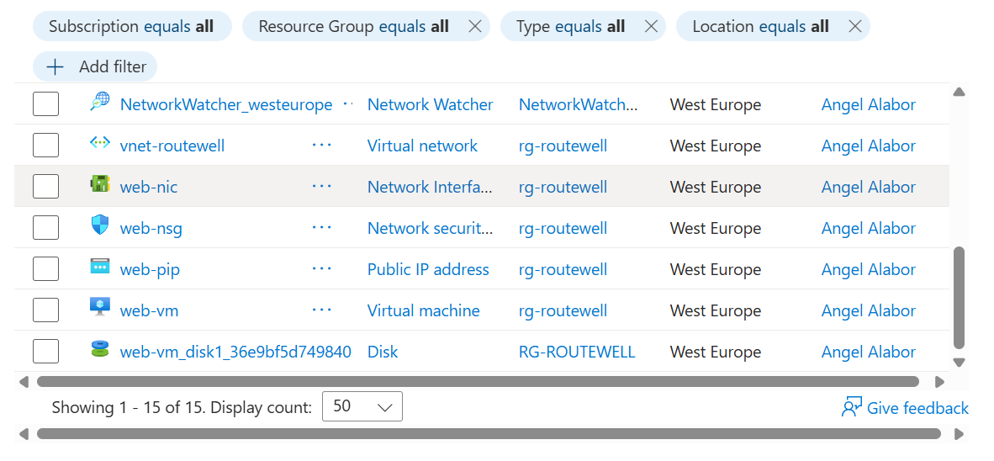
Figure B.1 — All resources inside rg-routewell: vnet-routewell, and the Web tier's NIC, NSG, public IP, VM, and disk.
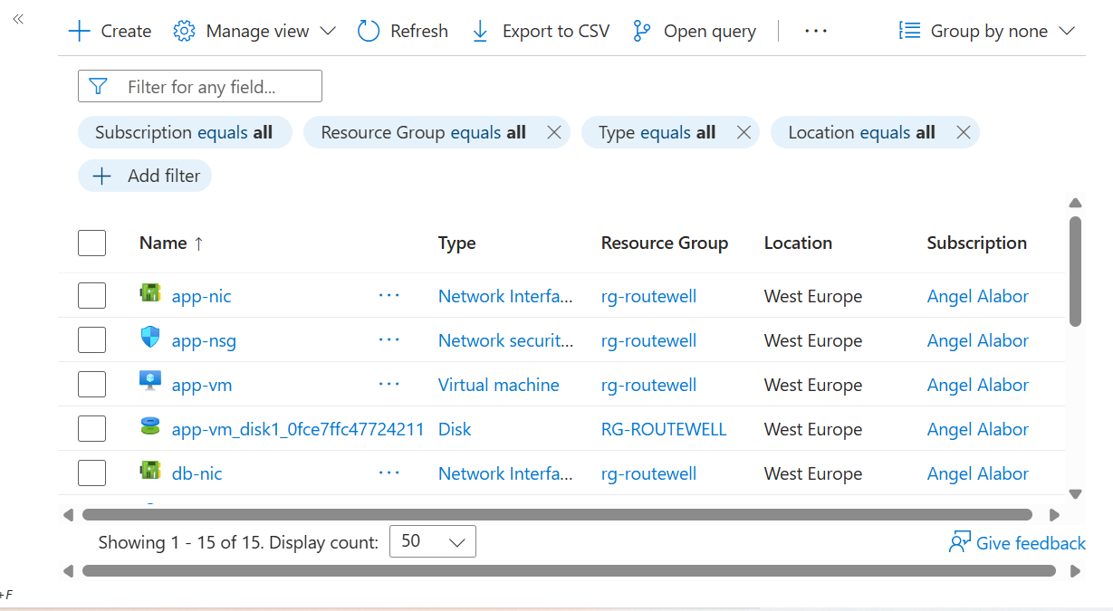
Figure B.2 — The remaining resources filtered to app- and db- prefixed items: app-nic, app-nsg, app-vm and its disk, and db-nic.
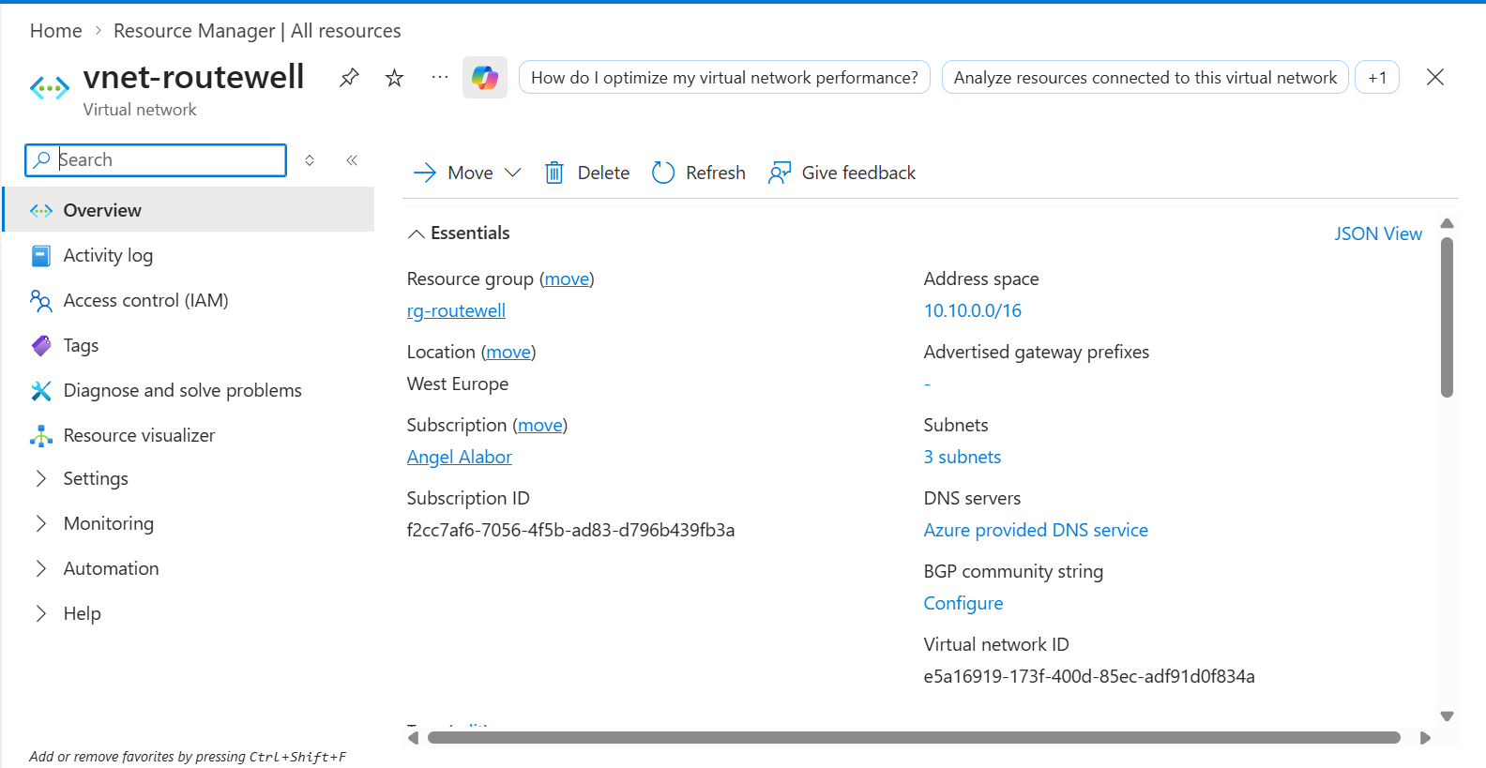
Figure B.3 — vnet-routewell overview: address space 10.10.0.0/16, 3 subnets, confirming the VNet matches the CIDR plan exactly.
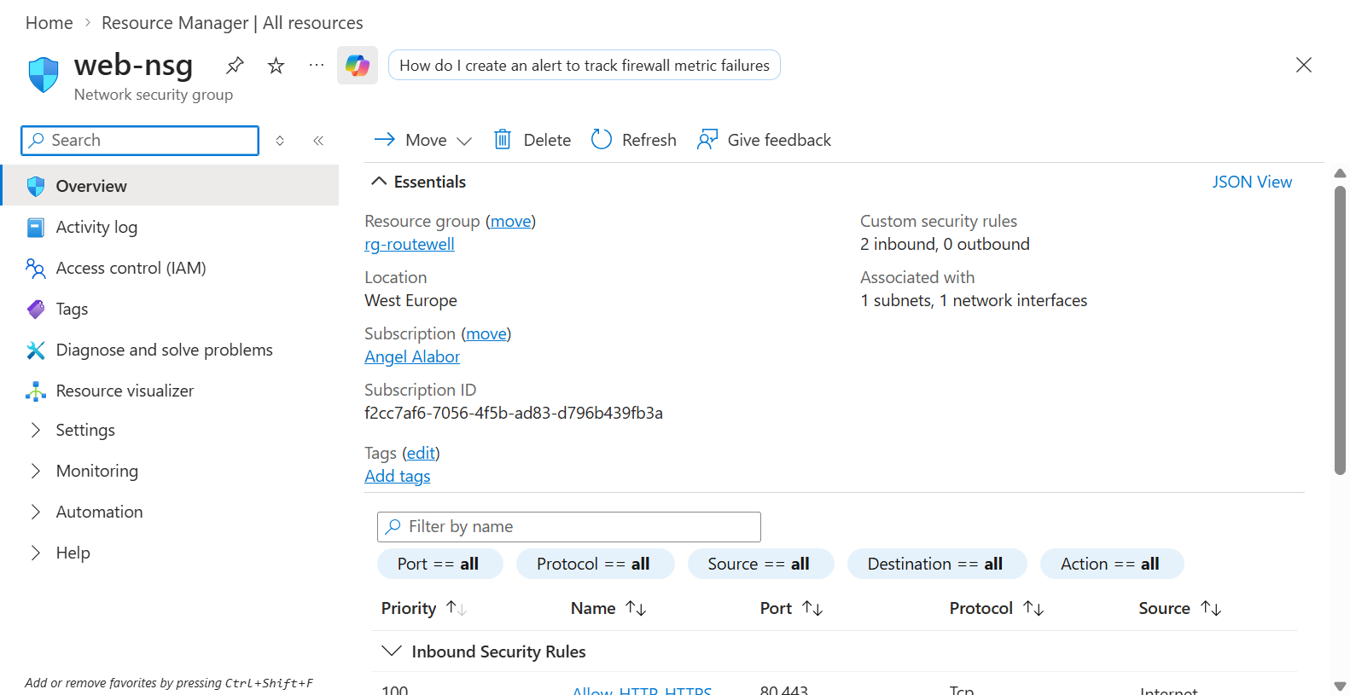
Figure B.4 — web-nsg: 2 inbound custom rules, associated with 1 subnet and 1 network interface, matching the design.
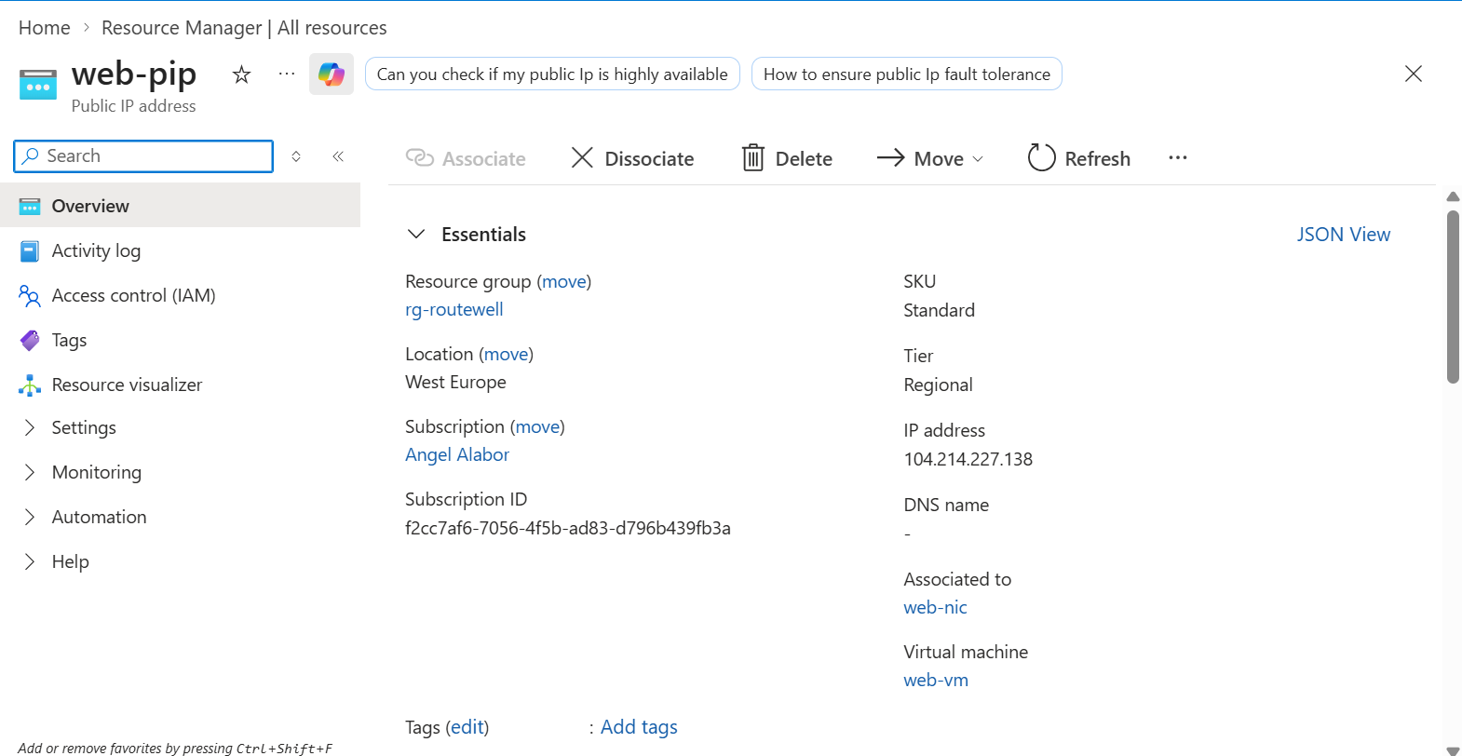
Figure B.5 — web-pip: Standard SKU, Regional tier, static IPv4 address 104.214.227.138, associated only with web-nic and web-vm.
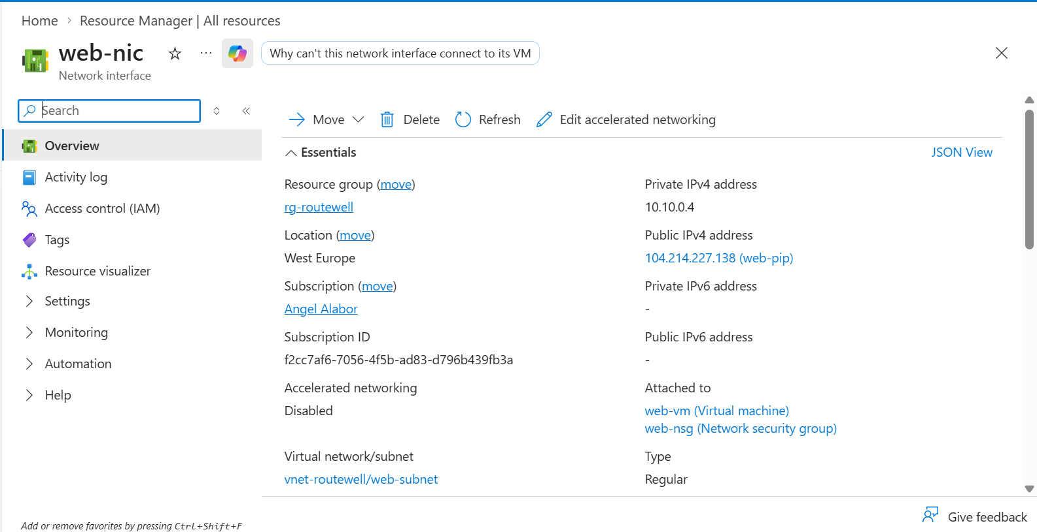
Figure B.6 — web-nic: private IP 10.10.0.4, public IP 104.214.227.138 attached, confirming Web is the one tier with internet-facing access.
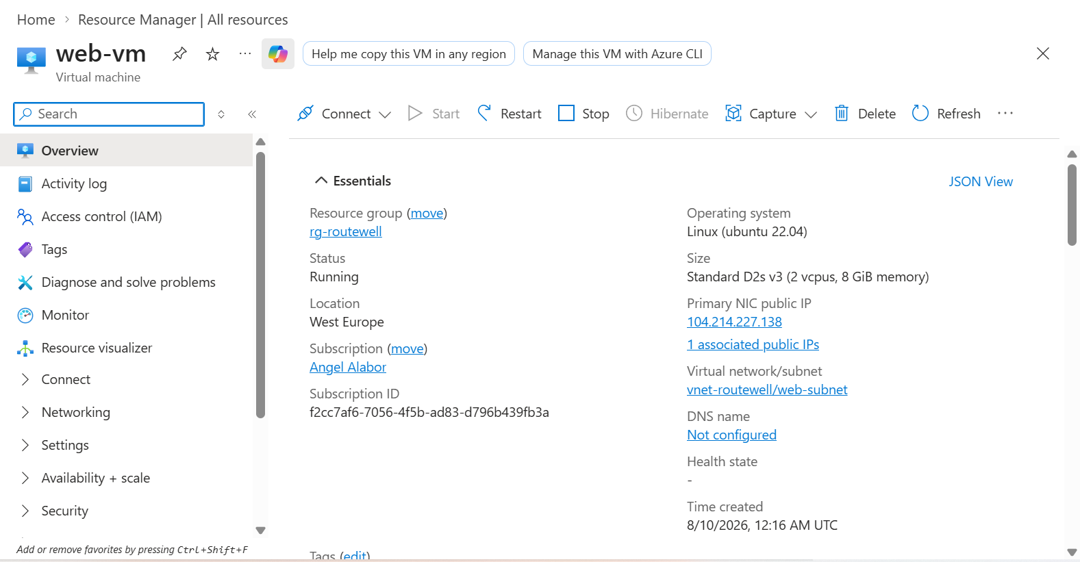
Figure B.7 — web-vm: Linux Ubuntu 22.04, Standard D2s v3, Running, on the web-subnet, with the public IP visible on the VM overview page.
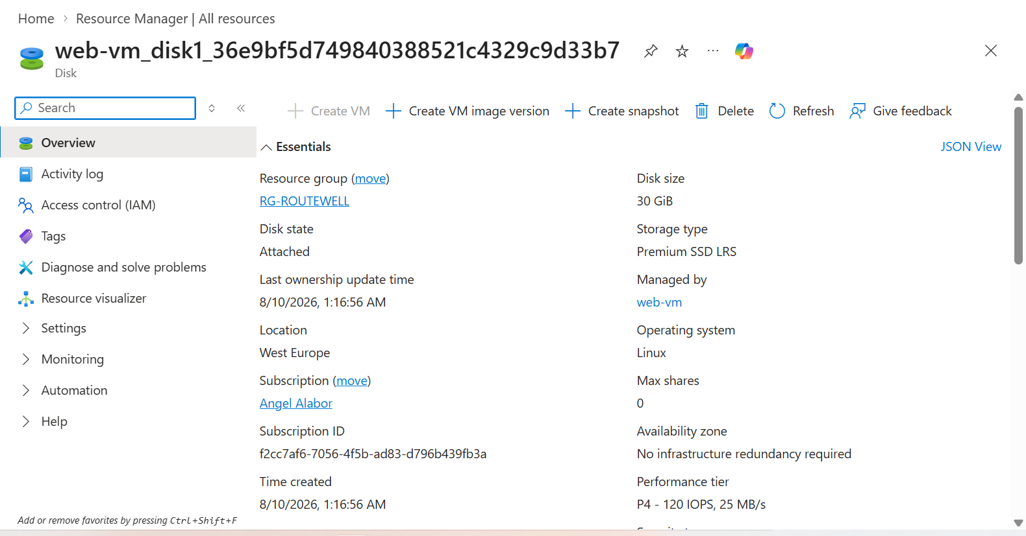
Figure B.8 — web-vm's OS disk: 30 GiB, Premium SSD LRS, Attached, managed by web-vm.
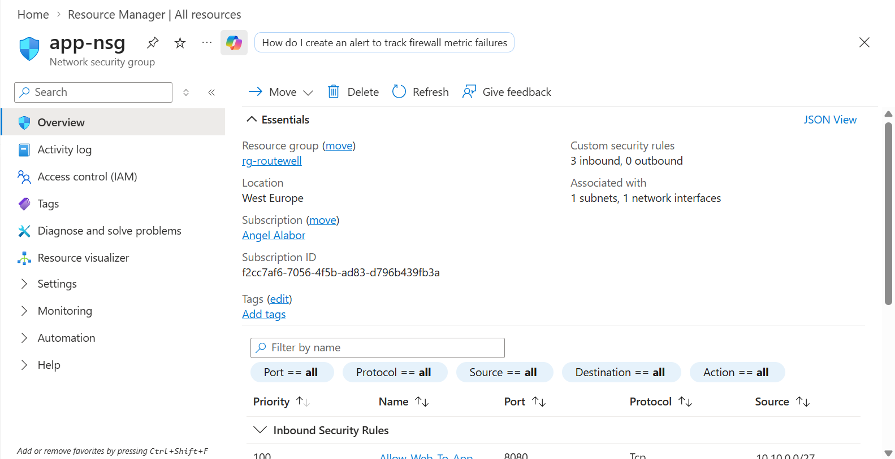
Figure B.9 — app-nsg: 3 inbound custom rules (Allow-Web-To-App, Allow-SSH, Deny-Other-VNet-Inbound), matching the jump-host design.
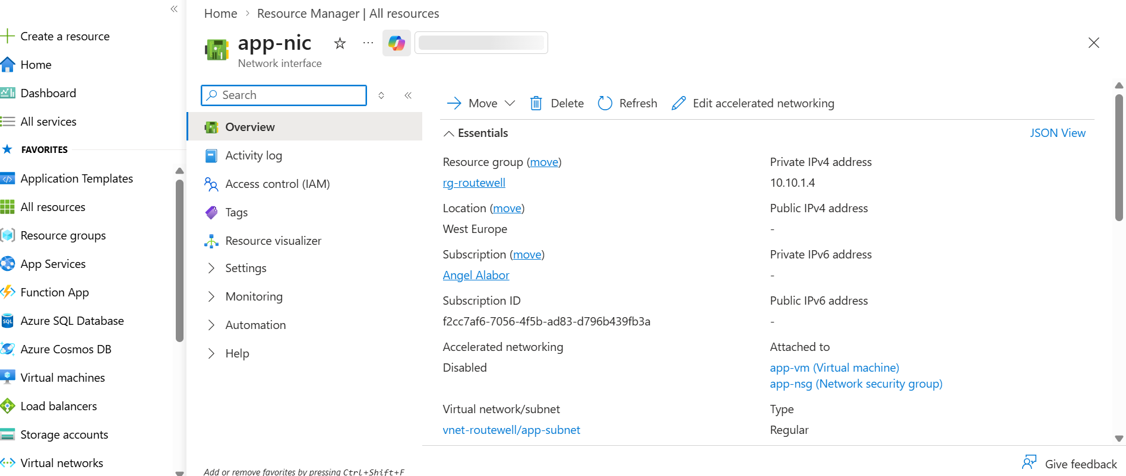
Figure B.10 — app-nic: private IP 10.10.1.4 only, no public IPv4 address at all — the actual mechanism enforcing that App is unreachable from the internet.
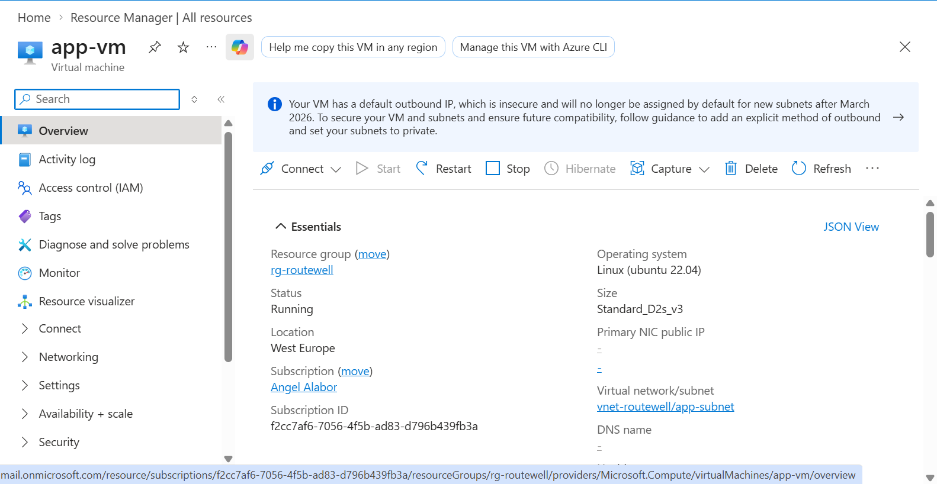
Figure B.11 — app-vm: Linux Ubuntu 22.04, Standard D2s v3, Running, Primary NIC public IP field showing empty (-), confirming no internet route exists.
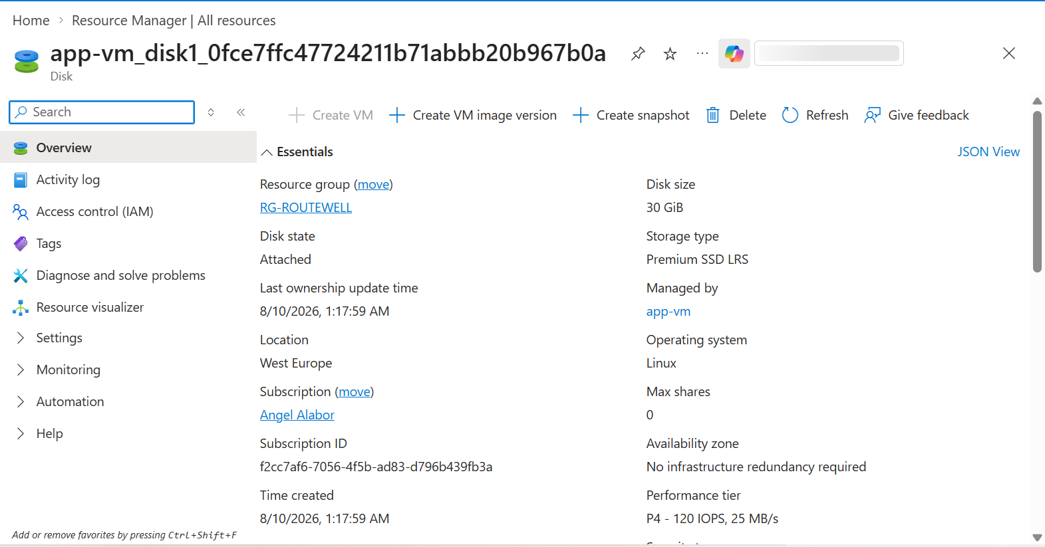
Figure B.12 — app-vm's OS disk: 30 GiB, Premium SSD LRS, Attached, managed by app-vm.
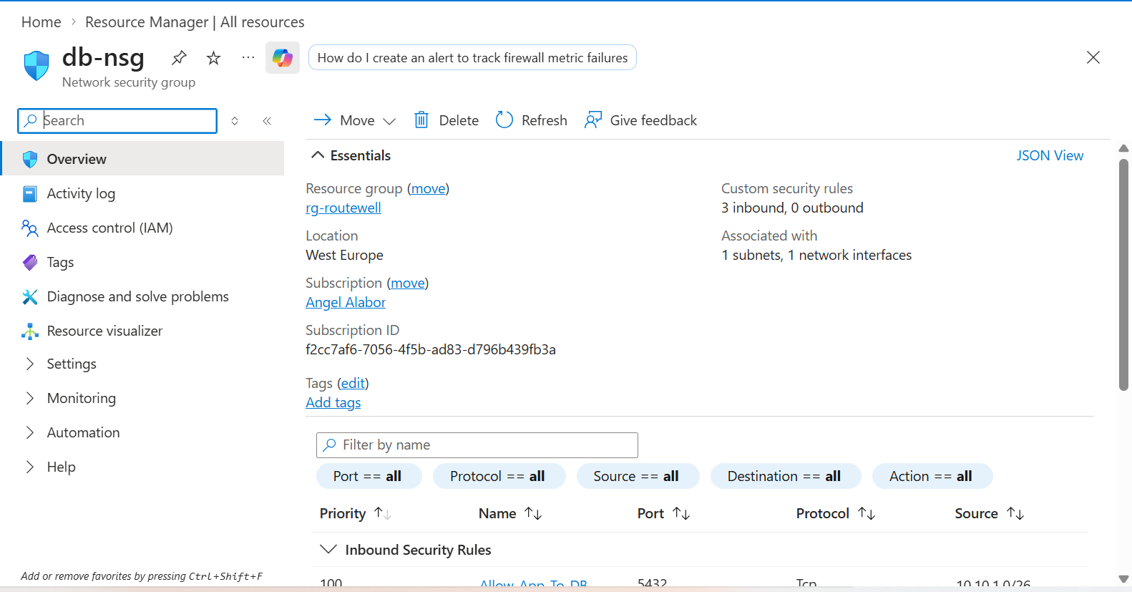
Figure B.13 — db-nsg: 3 inbound custom rules (Allow-App-To-DB, Allow-SSH, Deny-Other-VNet-Inbound) — the exact rule set responsible for closing the Problem 9 gap.
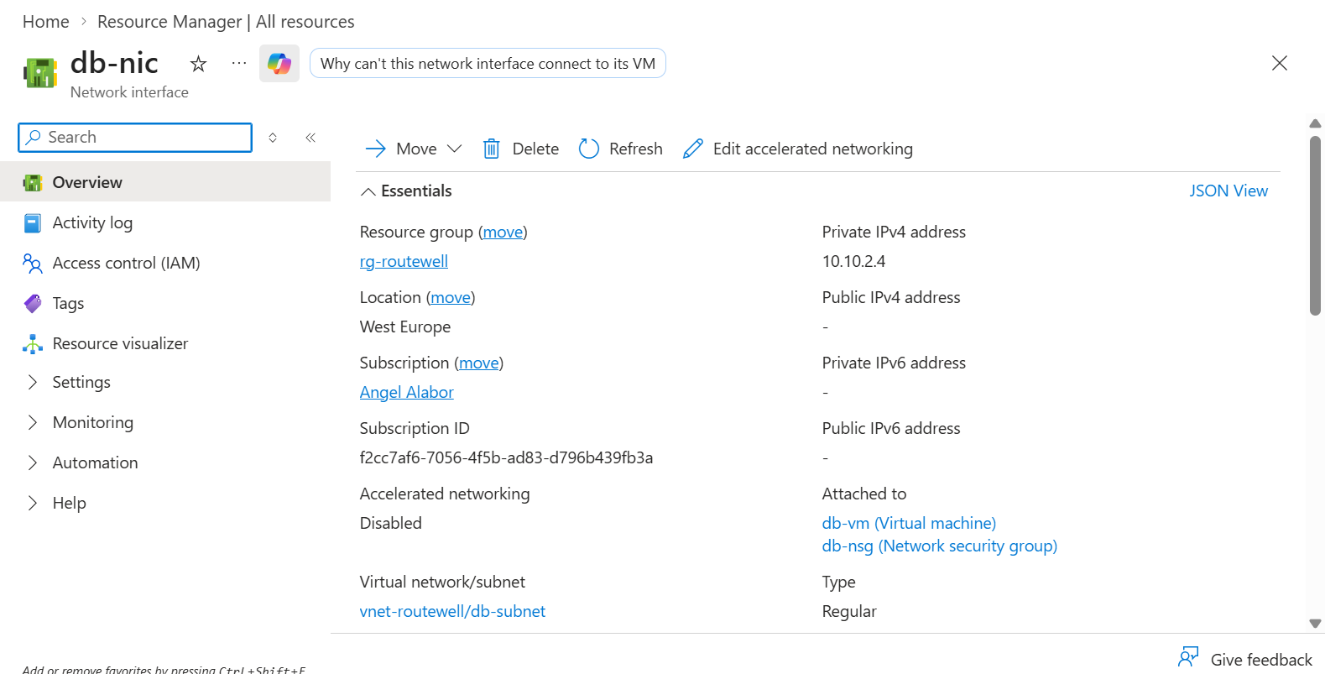
Figure B.14 — db-nic: private IP 10.10.2.4 only, no public IPv4 address — Database has no internet route under any circumstance, by design, not just by rule.
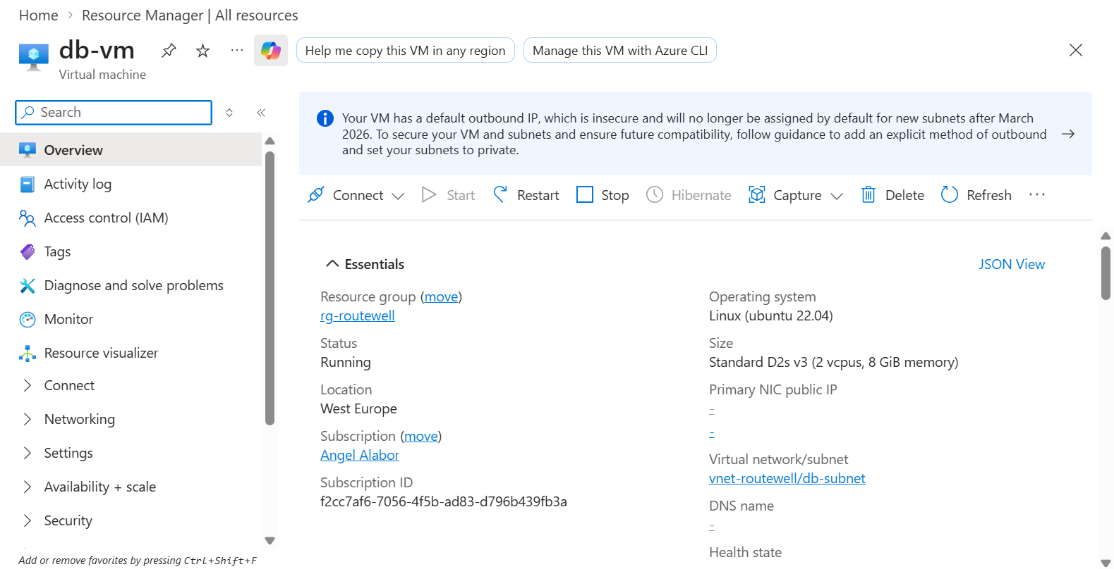
Figure B.15 — db-vm: Linux Ubuntu 22.04, Standard D2s v3, Running, no public IP, on the db-subnet — the tier holding the actual PostgreSQL data.
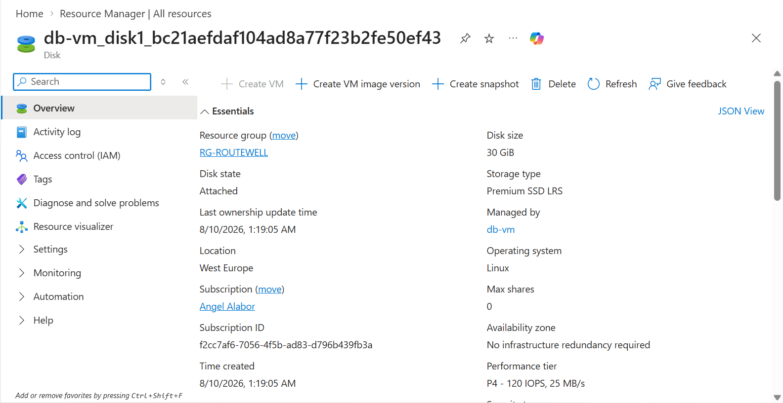
Figure B.16 — db-vm's OS disk: 30 GiB, Premium SSD LRS, Attached, managed by db-vm.

